GEORGIA MODEL CHILD ABUSE PROTOCOL

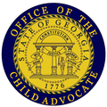

Note: The Model Child Abuse Protocol is inclusive of the sexual abuse and sexual exploitation provisions found in O.C.G.A. § 19-15-2(k).
PREFACE
Using the Model Protocol
Purpose: Why do we have a model and local Child Abuse Protocol (CAP)?
O.C.G.A. § 19-15-2 requires each county or circuit to establish a protocol for the investigation and prosecution of alleged cases of child abuse.
The purpose of the protocol is to ensure coordination and cooperation between all agencies involved in a child abuse case so as to:
- Increase the efficiency of all agencies handling such cases;
- Minimize the stress created for the allegedly abused child by the legal and investigatory process; and
- Ensure that more effective treatment is provided for the perpetrator, the family, and the child, including counseling.
This model protocol is designed to meet the statutory requirements for the county or circuit’s protocol in addition to the goals of effective collaborative multi-agency responses in child abuse investigations and prosecution at the local level and implementing a more uniform, multi-disciplinary response to child abuse throughout the state.
Customize your local protocol
This model protocol is designed to be just that – a sample that protocol committees may use as a guide to develop or revise their local protocol. In doing so, protocol committees should evaluate local resources and needs and incorporate them as appropriate. This is written with the assumption that each member agency will be familiar with and adhere to internal policies and procedures. Protocol committees should take into account the policies and procedures of each agency involved with the protocol and understand that laws, court rules, and operating procedures and orders may take precedence over the protocol in some circumstances. Where words are (italicized, underlined, and in parentheses), there are prompts for local protocol committees to further customize this model protocol by inserting locally-specific information. Further guidance may also be found in the footnotes or appendices.
A local protocol should not contain the page preceding this Preface titled “Georgia Model Child Abuse Protocol” or this Preface. However, a local protocol may incorporate information contained in this preface.
Training
Training for members of protocol committees, agencies with responsibilities under the protocol, and stakeholders is available from the Office of the Child Advocate for the Protection of Children (OCA). Training is available to address the general protocol provisions as well as specific subject matter. Please contact OCA via www.oca.georgia.gov or 404-656-4200 for further information or to request a training. Cross-training amongst protocol committee members and agencies is highly encouraged, as is notifying fellow protocol members of training opportunities within their organizations and the larger community.
Records and Meetings
The protocol committee shall have reasonable access to records concerning reports of child abuse. Information acquired by and records of a protocol committee shall be confidential, shall not be disclosed, and shall not be subject to the Open Records Act, or subject to subpoena, discovery, or introduction into evidence in any civil or criminal proceeding.
The meetings of the protocol committee in the exercise of its duties shall be closed to the public and shall not be subject to Chapter 14 of Title 50, relating to open meetings. Members shall not disclose what transpires at meetings nor disclose any information obtained during the meeting. Members may still testify regarding information about the case so long as the information was obtained independently of the protocol committee.

Thank you to all the agencies and individuals who participated in revising and updating this document. The Georgia Office of the Child Advocate is grateful for the feedback and input received throughout the years and is hopeful this document reflects that invaluable feedback such that communities find this document to be helpful in effectively responding to child abuse. A special thank you to the Children’s Justice Act, its advisory committee, and the Division of Family and Children Services for supporting and helping to fund this effort.

(Insert Name of County/Circuit) CHILD ABUSE PROTOCOL

Table of Contents

- Introduction………………………………………………………………………………………………………………3
- The Protocol Committee……………………………………………………………………………………………..4
- Child Abuse Prevention………………………………………………………………………………………………7
- Procedures for Investigating and Prosecuting Child Abuse Cases……………………………………8
  - Overview of Roles…………………………………………………………………………………………………8
  - Communicating with and Interviewing Children……………………………………………………..8
    - Children with Special Needs…………………………………………………………….9
    - Interviewing Children at School………………………………………………………10
    - Interviewing Children on Military Bases………………………………………….10
  - Reports of Child Abuse…………………………………………………………………………………………11
  - Multi-Disciplinary Response………………………………………………………………………………..13
  - Special Types of Investigations……………………………………………………………………………..17
    - Department of Early Care and Learning (DECAL)…………………………….17
    - Residential Facilities including Child Caring Institutions (CCIs), Youth Detention Centers (YDCs) or Regional Youth Detention Centers (RYDCs), and Psychiatric Residential Treatment Facilities (PRTFs).…..17
    - Allegations of Abuse in a School Setting……………………………………….….17
  - Forensic Interviews and Evaluations…………………………………………………………………….18
  - Prosecution and Court Processes...………………………………………………………………………..19
  - Additional Investigation and Prosecution Procedures by Topic……………………………….22
    - Family Violence (FV)……………………………………………………………………..22
    - Physical Abuse………………………………………………………………………………22
    - Sexual Abuse…………………………………………………………………………………23
    - Sexual Exploitation………………………………………………………..……………..24
    - Substance Use……………………………………………………………………………….26
    - Mental Health……………………………………………………………………………….27
    - Child Deaths, Near Fatalities, and Serious Injuries…………………………..28
- Methods to be Used in Coordinating Treatment Programs for the Child, the Family, and the Perpetrator………………………………………………………………………………………………………………28
- Additional Considerations…………………………………………………………………………………………30
- Resources………………………………………………………………………………………………………………..30
- Understanding and Agreement………………………………………………………………………………….30
- Signatures………………………………………………………………………………………………….…………….31
- Appendices………………………………………………………………………………………………………………31
  - O.C.G.A. § 19-15-2 (Child Abuse Protocol Governing Legislation)……………………………32
  - O.C.G.A. § 15-11-26 (Best Interest of the Child Factors)…………………………………………..35
  - Sample Annual Report…………………………………………………………………………………………36
  - Local, State, and National Resources…………………………………………………………………….37
  - Child Developmental Stages and Milestones………………………………………………………….45
  - Prevention-Focused Protective Factors and Efforts………………………………………………..52
  - Potential Indicators of Abuse……………………………………………………………………………….54
  - DFCS Mandated Reporter Form…………………………………………………………………………..57
  - Additional Information Regarding Forensic Interviews and Evaluations………………….61
  - Children’s Advocacy Centers of Georgia CSEC Response Team……………………………….63
  - Investigating Child Homicide Factsheet……………………………………………………………..…64

(Insert Name of County/Circuit)
CHILD ABUSE PROTOCOL

- Introduction
This Child Abuse Protocol (CAP) is established for (insert name of County/Circuit) consistent with O.C.G.A. § 19-15-2 for the investigation and prosecution of alleged cases of child abuse.

WHAT IS THE PURPOSE OF THE CAP? The purpose of this protocol is to ensure coordination and cooperation between all agencies involved in a child abuse case so as to:
1. Increase the efficiency of all agencies handling such cases;
2. Minimize the stress created for the allegedly abused child by the legal and investigatory process; and
3. Ensure that more effective treatment is provided for the perpetrator, the family, and the child, including counseling.

This protocol outlines in detail the procedures to be used in investigating and prosecuting cases arising from alleged child abuse and the methods to be used in coordinating treatment programs for the perpetrator, the family, and the child. As agencies coordinate and collaborate through a multi-disciplinary approach, communities can identify and implement solutions to issues related to the care and well-being of children.
TO WHOM DOES THE CAP APPLY? Children (under the age of 18) who may be victims of child abuse.
WHO IS BOUND BY THE CAP? All statutorily mandated committee members and signatories. The protocol is a guideline, not intended to be legal evidence of a standard of care, and compliance or noncompliance therewith is not intended for use in trial or court as relevant evidence. In case of any interpretation or conflict, or for requirements not addressed herein, the law will always take precedence.
WHAT CAN I EXPECT FROM THE CAP? The CAP can:
- Reduce trauma to children by improving interagency coordination to reduce the number of times a child has to tell his/her story of abuse.
- Improve the opportunity for children to heal from trauma by encouraging the system to be responsive and accountable.
- Delineate professional roles and responsibilities.
- Establish standards for points of contact, methods of contact, and purposes of contact between these agencies.
- Identify the steps that must be completed as part of the investigation and prosecution processes, the time frames associated with those steps, and the persons responsible for completion of those steps.
- Strengthen and clarify relationships between child abuse response agencies.
- Inform and educate stakeholders and the community about the response to reports of abuse.
- Ensure that cases are handled in a consistent manner, while recognizing that each individual child and family requires a unique response.
- Provide a concrete and practical plan for addressing special issues that may arise.
- Improve communication, credibility, and accountability of committee members.
HOW DOES THE CAP DIFFER FROM THE MDT, LIPT, AND CFR? The CAP is a comprehensive guide to the handling of all child abuse cases, including sexual abuse and sexual exploitation. The Multi-Disciplinary Team (MDT) is one part of the process that should be incorporated into the CAP; this team is focused on reviewing individual cases of sexual abuse and severe physical abuse to collaborate for appropriate intervention and treatment. The Local Interagency Planning Team (LIPT) is another part of the process that should be incorporated into the CAP as it focuses on ensuring appropriate services are in place for children with mental health and behavioral health needs. The local Child Fatality Review (CFR), supported by the statewide Child Fatality Review housed within the Georgia Bureau of Investigation (GBI) is yet another part of the process that may be incorporated into the CAP as it focuses on reviewing cases where a child has died or suffered a near fatality or serious injury; part of CFR’s goal is to understand what led to the incident and what prevention efforts are needed moving forward.
In preparing this protocol, we acknowledge that child abuse exists and that the experience of any such abuse has a negative impact on the child, and, ultimately, society. Each of us, as a signatory agency and as an individual, has a responsibility to respond to allegations of child abuse properly. It is necessary for each of us to be aware of our own biases and prejudices so as to reduce the potential for disproportionality throughout the systems in which we operate. Further, we recognize that no one agency or discipline can address any one instance of child abuse alone, given the significant complexities that are involved. Appropriate responses and interventions are multi-faceted and require each participating agency, with its own body of knowledge, procedures, and mandates, to work with each other to ensure an individualized response for each situation. This protocol can be viewed as a strategy for effective intervention as we seek to mobilize our strengths to better serve child victims and their families. It is our collective and unified desire to minimize the trauma to the child and to prevent further abuse.
The following procedures represent a cooperative effort on the part of the protocol committee members in (insert county/circuit name) who respond to child abuse. This protocol recognizes that no protocol can purport to offer a comprehensive set of guidelines for the infinite number of circumstances that human service providers face daily. When workers face situations not specifically covered by this Protocol, they are urged to use the protocol in conjunction with agency supervision and their own judgment to provide safety and welfare for the children of (insert county/circuit name). The signatories to this protocol are committed to continuing as an interagency committee as required by law and to periodically review and refine this interagency protocol for responding to child abuse. In so doing, the protocol committee will identify critical issues, needs, and resources required to facilitate and enhance the prevention, investigation, and prosecution of child abuse.

- The Protocol Committee
The chairperson of the (insert name of County/Circuit) Child Abuse Protocol Committee is (insert chairperson’s name). This committee also consists of the following members:
- (Insert name/title of representative from the sheriff’s office of each county participating in this protocol)
- (Insert name/title of representative from the county Division of Family and Children Services for each county participating in this protocol)
- (Insert name/title of representative from the district attorney for the judicial circuit)
- (Insert name/title of representative from the presiding juvenile court judge for each county participating in this protocol)
- (Insert name/title of representative from the chief magistrate of each county participating in this protocol)
- (Insert name/title of representative from the county board of education or each board of education in the judicial circuit participating in this protocol
- (Insert name/title of representative from the county mental health organization of each county participating in this protocol)
- (Insert name/title of representative from the chief of police of the county, if any, of each county participating in this protocol)
- (Insert name/title of representative from the chief of police of the largest municipality in the county/circuit)
- (Insert name/title of representative from the county public health department of each county participating in this protocol)
- (Insert name/title of representative from the coroner or county medical examiner of each county participating in this protocol)
- (Insert name/title of representative from a local child advocacy center if one exists in the county/circuit)
- (Insert name/title of representative from a sexual assault center if one exists in the county/circuit)
- (Insert name/title of representative from a local citizen or advocacy group which focuses on child abuse awareness and prevention, as designated by the chief superior court judge)
- (Insert names/titles of additional members as necessary and proper to accomplish the purposes of the protocol committee. Additional members may include representatives of medical providers; service providers; psychiatrists; victim advocates; CASA/guardians ad litem; city boards of education; the local community service board; human trafficking prevention and intervention; a military family advocacy program or criminal investigation division; additional law enforcement such as local college police; fire department(s) and emergency medical technicians (EMTs); Department of Juvenile Justice; Department of Corrections and Probation; housing authority; transporters; faith leaders; community organizers or advocates; prevention-focused organizations; and youth and parents with experience with the child welfare system)
Consistent with O.C.G.A. § 19-15-2, this committee and the agencies subject to this protocol agree to:
- Adhere to this protocol;
- Receive training as necessary and consistent with O.C.G.A. § 19-15-2;
- Collaborate, coordinate, and cooperate with each other and others;
- Interact respectfully and non-discriminatorily with each other as well as the children, parents, families, and alleged perpetrators with whom they encounter;
- Respond to cases of alleged child abuse efficiently;
- Minimize stress created for the child by the legal and investigatory process by being trauma-informed and operating in a trauma-responsive way;
- Ensure that effective treatment, including counseling, is provided for the child, the family, and the perpetrator;
- Facilitate and support agencies, organizations and individuals whose efforts are directed toward abuse prevention;
- Be familiar with each person’s/agency’s responsibilities, including their own, as well as other agency’s responsibilities. Recognize how any one person’s or agency’s role affects other agencies and roles;
- Consistent with confidentiality and privacy laws, share information with each other;
- Close the committee’s meetings to the public and participate in committee meetings;
- File the protocol with the Office of the Child Advocate and the Georgia Division of Family and Children Services. Meet at least twice annually for the purpose of evaluating the effectiveness of the protocol and modifying and updating the same. File updated protocols with these state agencies by September 1 of each year;
- Issue an annual report no later than July 1 of each year. Transmit this annual report to the county governing authority, the fall-term grand jury of the judicial circuit, the chief superior court judge of the circuit, and the Office of the Child Advocate for the Protection of Children and include the following:
  - An evaluation of the extent to which investigations of child abuse during the 12 months prior to the report have complied with the protocol;
  - A recommendation of measures to improve such compliance; and
  - A description of which measures have been successful in preventing child abuse within the county or circuit. This could include prevention activities such as enhanced primary care; behavioral parent training programs; treatment to lessen harms of abuse exposure; and treatment to prevent problem behavior and later involvement in violence.

- Child Abuse Prevention
Child abuse is preventable; it is not inevitable. It rests on the principle that all children should have safe, stable, nurturing relationships and environments. Child abuse is not typically caused by a single factor, but rather is influenced by multiple complex factors related to the individual, family, community, and greater society. As such, it requires a public health approach involving the entire community to prevent and treat child abuse. Much progress has been made in understanding how to prevent child abuse and many common informal and everyday actions in addition to formalized evidence-based prevention focused programs all count towards prevention efforts. Fortunately, preventing child abuse can also help prevent other forms of violence and lead to healthier individuals and communities.
Effective prevention involves strategies, programs and connections to resources that support families within their communities. It is enhanced by a multi-disciplinary approach throughout the community that involves coordination, collaboration, and positive working relationships amongst all levels of public and private agencies, individuals, groups, and disciplines involved in prevention and treatment of child abuse. Prevention strategies can be implemented before abuse or trauma occurs or after abuse has occurred to prevent subsequent abuse. Prevention programs may fall under several different categories, including public awareness efforts, parent education and support groups, and community prevention efforts.
The goals of prevention in the CAP include developing and maintaining healthy nurturing communities; identifying the methods that have been implemented to prevent child abuse; tracking statistical information relating to prevention methods and child abuse cases; and utilizing data to determine needed community prevention and treatment services.
Prevention efforts, including primary, secondary, and tertiary efforts, in place in (insert county/circuit name) include:
- (Include all relevant prevention efforts and related contact information)
- (Include as many additional relevant efforts and activities with related contact information as necessary)

- Procedures for Investigating and Prosecuting Child Abuse Cases
4.1 Overview of Roles
Each committee member and the agencies/entities each member represents has an important role to fulfill in the investigation and prosecution of child abuse cases:
- Mandated reporters, including education personnel and medical personnel among others, are primarily responsible for identifying and reporting suspected child abuse.
- Law enforcement is primarily responsible for investigating a situation to determine whether a crime has been committed; identifying and apprehending the offender(s); and filing appropriate criminal charges.
- DFCS is primarily responsible for responding to reports of abuse to determine if maltreatment occurred; assessing safety and risk; ensuring the safety of the alleged victim and any other children in the home; and ensuring the family has access to appropriate services.
- Child advocacy centers (CACs) are primarily responsible for conducting forensic interviews to inform the investigations conducted by law enforcement and DFCS.
- Medical personnel, mental health organizations and counselors, child advocacy centers, and sexual assault centers provide exams, diagnoses, and treatment.
- Coroners and medical examiners evaluate and determine a person’s manner and cause of death. Their findings may inform the criminal or civil response to cases involving child abuse.
- Superior Courts maintain jurisdiction for felony criminal matters related to child abuse. State Courts handle misdemeanor trials (domestic violence cases). Magistrate courts are primarily involved in child abuse cases through the issuance of criminal warrants against perpetrators, the holding of probable cause hearings, and setting bond and/or conditions of bail. District attorneys and the Solicitor’s office are responsible for prosecuting criminal actions of child abuse.
- Juvenile Courts maintain jurisdiction for dependency matters related to child abuse.
- (Include roles of other stakeholders that are participating in this protocol.)

  - Communicating with and Interviewing Children
At the time a child makes a disclosure of abuse or an adult otherwise has a suspicion that the child is being or has been abused, the adult should be careful to gather only enough information to determine if a report is necessary.
Any communication with a child should be respectful, trauma-informed and responsive, developmentally appropriate, and sensitive to that child’s particular needs, culture, and language. When allegations or concerns of abuse exist, the child should be interviewed about these allegations outside of the presence of the parent/caregiver/alleged perpetrator, and only by a trained, appropriate forensic interviewer. Give special consideration to the child’s safety following a disclosure of abuse, especially if the parents/alleged perpetrator have been informed of the interview or disclosure and whether the alleged perpetrator continues to have access to the child.
When conducting joint investigations, responders will work collaboratively to determine who will take the lead role on interviewing the child. Generally, it will be a forensic interviewer through the CAC.
A rapport should be established between the child and the interviewer. Then the interviewer should assess the child’s development and level of understanding in a manner consistent with the Child First protocol or another nationally recognized forensic interview protocol. The interview should be stopped if the child appears to be too distressed or too uncomfortable.
    - Children with Special Needs
All agencies are required to adhere to federal laws and regulations related to people with disabilities, specifically, Title II of the Americans with Disabilities Act (ADA) and Section 504 of the Rehabilitation Act of 1973. Collectively, these laws prohibit public and private entities from discriminating against people with disabilities and ensure equal opportunity to participate in and benefit from a wide range of services and programs. These requirements include accommodations for communication and requirements for accessibility to services, which requires “state and local government programs [to] ensure effective communication with individuals with disabilities by providing appropriate auxiliary devices.” The requirements include “furnish[ing] auxiliary aids when necessary to ensure effective communication, unless undue burden or fundamental alteration would result.” There should also be no discrimination on the basis of a disability by public accommodations.
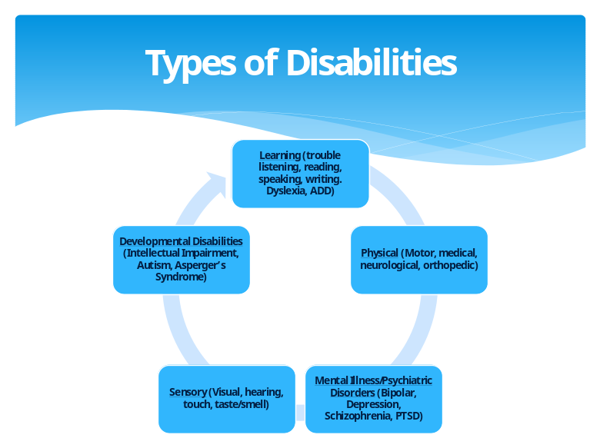
Everyone that is subject to this protocol agrees to adhere to Title II of the ADA and Section 504 of the Rehabilitation Act throughout the entirety of their involvement with anyone to whom these laws are applicable. Adhering to these laws includes the following:
- Establish rapport and respectful communication with the child. Assume the child is competent unless/until you learn otherwise.
- Determine whether the child has a disability. If so, determine how the child best communicates his or her wants and needs; determine what makes it easiest for the child to understand what others communicate; determine what, if any, accommodations are needed and when they are needed; and provide such accommodations.
- Create a safe and non-judgmental environment.
- Do not ask for a lot of details or rephrase questions as it may cause confusion.
- Do not touch the child as this could cause a fight or flight response in children with certain disabilities.

    - Interviewing Children at School

- Child abuse-related interviews by DFCS, the district attorney’s office, and/or law enforcement may be conducted at the child’s school during school hours. In such cases, school staff should assist these agencies by providing a private setting conducive to interviewing children. No school district employee or school-allied volunteer will contact a parent/guardian regarding the interview of their student in child abuse referrals.
- Anyone seeking to conduct an interview with a child at school will endeavor to reduce disruption at the school and for the child.
- When planning to conduct a preliminary or subsequent interview at school, DFCS staff or law enforcement may contact school personnel prior to being on site for the interview.
- Upon arrival to the school, the interviewer should be prepared to sign-in and show proper identification/authorization.
- The school personnel will facilitate arranging the private location and logistics for preliminary or subsequent interviews.
- A child will not be detained beyond normal school hours nor will the child be transported by DFCS without the permission of the parent or legal guardian or an appropriate court authorization. If a child is removed from school by a DFCS caseworker or law enforcement officer, the child’s parent or legal guardian will be notified by either DFCS or law enforcement. If the child’s parent/legal guardian contacts the school, that person will be referred to DFCS or the appropriate law enforcement agency.
- School personnel will check in with the child following an interview that takes place at the school to determine whether the child would like some time to process the interview or otherwise receive support from a school counselor.
- If the school is part of the ongoing treatment plan for the child, DFCS will keep the school informed about the subsequent findings and plans for the child and family. The goal is to share information and it will be the responsibility of DFCS to attempt to include the school as part of their treatment plan through case documentation.
- If school is not in session or the child is pre-school age, the DFCS and law enforcement representatives will make a decision as how best to interview the child away from the alleged perpetrator.

    - Interviewing Children on Military Bases

- DFCS will provide notification of the initial report of child abuse to the respective Family Advocacy Program (FAP) and military law enforcement as outlined in O.C.G.A. § 19-7-5.
- When planning to conduct a preliminary or subsequent interview on a military installation, DFCS should contact the FAP or military law enforcement to obtain access to the military installation and/or government housing areas.
- Upon arrival to the military installation, DFCS should be prepared to show proper identification/authorization and sign in.
- The initial investigation of child abuse involving military personnel and their family members may be coordinated with the respective FAP and military law enforcement.
- DFCS will seek assistance from the FAP and military law enforcement in evaluating, assessing and determining an appropriate treatment plan for cases involving child abuse.

  - Reports of Child Abuse
WHAT IS CHILD ABUSE? Child abuse is defined as:
- Physical injury or death inflicted upon a child by a parent or caretaker thereof by other than accidental means (provided, however, that physical forms of discipline may be used as long as there is no physical injury to the child).
- Neglect or exploitation of a child by a parent or caretaker thereof.
- Endangering a child, which includes the following acts:
    - Cruelty to children in the third degree. This includes a primary aggressor intentionally causing or permitting a child to be present and seeing or hearing a forcible felony, battery, or family violence battery.
Mandated Reporters Include:
➢ Physicians, licensed to practice medicine, physician assistants, interns, or residents
➢ Hospital or medical personnel
➢ Dentists
➢ Licensed psychologists & interns
➢ Podiatrists
➢ Registered professional nurses or licensed practical nurses
➢ Licensed professional counselors, social workers, or marriage and family therapists
➢ School teachers, including daycare providers
➢ School administrators
➢ School guidance counselors, visiting teachers, school social workers, or school psychologists
➢ Child welfare agency personnel
➢ Child [serving] organization personnel (employees and volunteers)
➢ Law enforcement personnel
➢ Reproductive health care facility or pregnancy resource center personnel and volunteers
O.C.G.A. § 19-7-5(c)(1)
    - Intentionally causing or permitting a child to be present where any person is manufacturing meth or possessing a chemical substance with the intent to manufacture meth.
    - Driving under the influence with a child under the age of 17 years in the car.
    - Prenatal abuse.
- Sexual abuse of a child.
    - Includes consensual sex acts when the sex acts are between minors if any individual is less than 14 years of age.
    - Does not include consensual sex acts when the sex acts are between a minor and an adult who is not more than four years older than the minor.
    - This provision of the law shall not be deemed or construed to repeal any law concerning the age or capacity to consent.
- Sexual exploitation.
- Emotional abuse.

REPORTING CHILD ABUSE. Reports of child abuse may come from mandated reporters or non-mandated reporters. Mandated reporters are required to make a report to DFCS immediately, but in no case later than 24 hours from the time there is reasonable cause to believe that suspected child abuse has occurred. Some mandated reporters may have the requirement to notify a designated person within their agency who will have the responsibility to notify DFCS of the report on that person’s behalf. Mandated reporters will not conduct their own detailed interview, but will gather sufficient information to determine if a report is necessary.
(Identify name/title, contact information, and any relevant specifics of each local agency’s designated delegate for making reports of suspected child abuse to DFCS. This may include schools, behavioral health service providers, etc.)
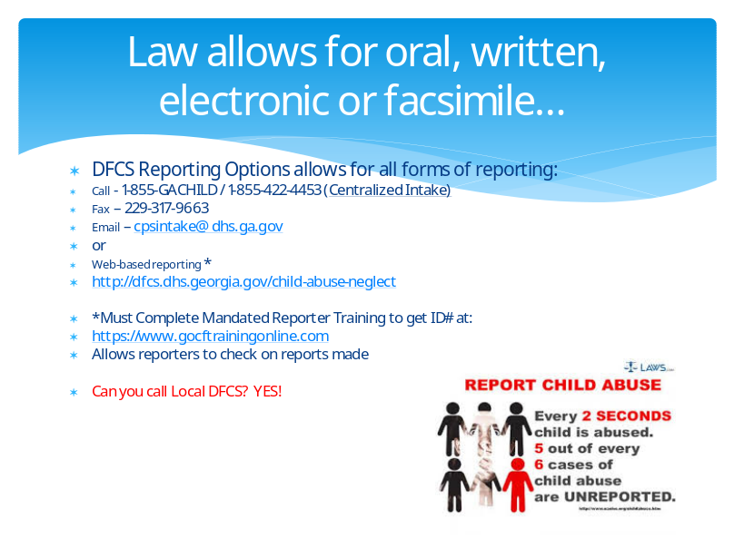
WAYS TO REPORT ABUSE: Reports of suspected child abuse are made via DFCS’s Child Protective Services (CPS) Intake Communication Center (CICC) by phone, email/fax, or an online web form. When making a report of suspected child abuse, it is helpful for a reporter to include the following information when known:
- The name(s), address(es) or physical location, and age(s) of the child(ren);
- The name(s) of the child(ren)’s parents or caretakers;
- The nature and extent of the allegations of abuse, including any knowledge or evidence of previous allegations of abuse; and
- Any other information, including photographs, in establishing the cause of the abuse, protective capacities of the parents, and the identity of the alleged maltreator(s) or any other information that the reporter believes will be useful.
Mandated reporters will carefully consider whether it is appropriate to disclose to the parents/guardians or legal custodians of the child that a report is being made to protective services, especially given that the report is being made with the child’s safety in consideration. DFCS will adhere to legal requirements by not disclosing from whom DFCS received a report.
Mandated reporters will also maintain a child’s right to confidentiality and adhere to privacy laws. Information regarding diagnosis, current condition, and prognosis should be shared only as necessary in response to pertinent questions posed by protective services personnel. No release of information is required to make this report.
Upon receipt of a report of child abuse for which DFCS has reasonable cause to believe such report is true or the report contains any allegation or evidence of child abuse, regardless of the intake disposition, DFCS will notify law enforcement or the district attorney, and will also notify military law enforcement and family advocacy programs, when the parent/guardian of the alleged victim child is on active duty in the U.S. armed forces.
Also upon receipt of an allegation of child abuse, the DFCS CPS Intake Communication Center (CICC) will make a determination whether a report contains allegations of maltreatment and assign a response time based on the indication of a safety threat to the child. This determination may result in acceptance for further assessment and intervention, a screen out with a referral for services, or a screen out. If accepted for further assessment and intervention, DFCS may assign it to the investigative track or for supportive family services.
Law enforcement, DFCS/the juvenile court, and physicians (in limited circumstances) have the ability/authority to remove a child.
(Insert specific local procedures for removal, including any by law enforcement and physicians.)
  - Multi-Disciplinary Response
A coordinated, multi-disciplinary response is a critical and vital component to the investigation and prosecution of child abuse cases and involves consistent communication; cross-reporting of allegations; joint investigations and collaborative interviewing; and multi-disciplinary case reviews. The goals of a coordinated response are to ensure an appropriate response to concerns of child abuse; minimize the number of interviews a child undergoes; ensure sensitive treatment of the child victim and their family; preserve the integrity of an investigation that may lead to court involvement; enhance the quality of evidence discovered for civil litigation or criminal prosecution while eliminating duplication of efforts; and provide information essential to family treatment agencies. Early cooperation minimizes the likelihood of conflicts among agencies and different philosophies or mandates and encourages consistent reporting practices.
While law enforcement and DFCS shoulder primary initial responsibility for responding to reports of child abuse, and therefore must work closely together, they cannot do their work well without an incredible number of partners. Each report of child abuse brings with it its own set of circumstances and uniqueness. Each entity has a critical role to serve in the child welfare and protection system and necessarily must refer to their own sets of policies and procedures. However, working as a larger team and relying on each other for consultation helps ensure a child receives the most appropriate response possible. As such, law enforcement, DFCS and their partners and participating disciplines should educate each other on their respective roles, abilities, and limitations when responding to child abuse cases such that everyone understands the dynamics of victimization, child development, and the civil and criminal justice process as it relates to children.
CONSISTENT COMMUNICATION.
- All committee members agree to maintain regular and ongoing contact and communication with each other for any case of child abuse for which they are involved. In doing so, committee members will ensure others involved are aware of the necessary contacts and contact information throughout the life of the case.
- (Insert additional specific procedures related to communication.)
CROSS-REPORTING OF ALLEGATIONS. Any committee member that becomes aware of an allegation of child abuse will make a report consistent with the law and the preceding procedures. (insert county/counties) DFCS and (insert jurisdiction) law enforcement will notify each other when they have received a report containing an allegation of child abuse and have reasonable cause to believe that the allegation is true. Contact may be made with the reporter(s) to gather additional information and obtain any needed clarity. Notifications and cross-reporting of suspected child abuse and related communications will occur in cases including, but not limited to, the following:
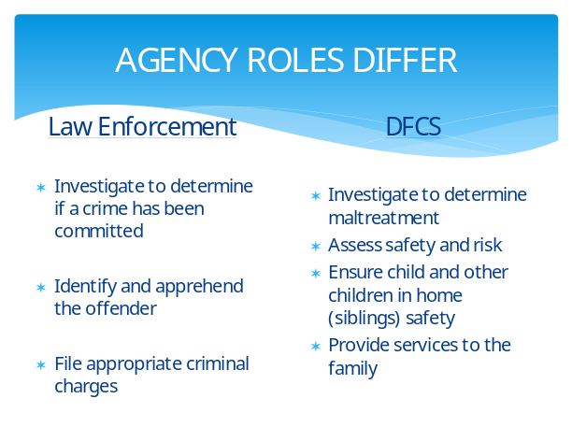
- Sexual abuse involving a child
- Sexual exploitation of a child
- Substance use in the home, including by parents or children
- Family violence, intimate partner violence, or domestic violence
- Physical abuse involving a child
- Severe emotional abuse
- Severe neglect involving a child for which DFCS requests assistance
- Refusal by a family to allow a DFCS worker to see the child victim in any abuse investigation or response
- The presence of any serious injury on a child for which the explanation offered is inadequate to explain the injury
- Any referral of abuse indicated by a physician
- Munchausen by proxy/pediatric condition falsification/factitious disorder by proxy
- Any suspicious death of a child
- Cases involving child-on-child abuse
- (Insert any additional relevant types of cases)
JOINT INVESTIGATIONS AND COLLABORATIVE INTERVIEWING.
All committee members will:
- Be familiar with this protocol and adhere to it unless law dictates otherwise.
- Evaluate each situation case-by-case.
- Interact respectfully with each other and children, parents, alleged perpetrators, and any other person involved in a child abuse case, including colleagues from other jurisdictions.
- Give immediate consideration to the child’s safety. If out-of-home placement is necessary for the child’s safety, consideration will be given to relatives and fictive kin who may be able and willing to provide appropriate care for the child.
- Document (photos/videos/notes) any potential evidence, such as marks or bruises, as appropriate. Share documented information with other relevant protocol members.
Specifically as it relates to law enforcement and DFCS, (insert jurisdiction) law enforcement and (insert county/counties) DFCS will:
- Initiate investigations in accordance with relevant laws and internal policies. Arrange for medical attention, if necessary. Secure the crime scene, gather evidence, and obtain statements, as appropriate. Law enforcement will receive all physical, biological, drug and gun evidence, including sexual assault kits.
- Law enforcement will accompany DFCS upon a request from DFCS to do so when necessary for securing parental cooperation, access to the child, or protection of the child.
- Conduct an initial screening/review their records and histories [of suspects] whenever possible prior to making a decision on the disposition of a referral and share information about past histories contained in their records with each other.
- Confer with each other and make a preliminary determination as to whether the allegations are founded, and, if so, whether it is appropriate to pursue it as a criminal and/or civil matter.
- Inform one another and any other relevant involved agency of their respective decisions regarding the disposition of any jointly investigated case.
- Notify, consult and communicate with the district attorney regarding prosecution, when appropriate.
- Make any necessary referrals for appropriate services, including those provided through the Victim Assistance Program.
- Have a representative with advanced cross-training as it relates to child abuse investigations, sexual assault, human trafficking, and severe cases. These representatives will operate as liaisons for each agency and serve as a resource for their colleagues, especially for more severe cases of child abuse reported to the agency.
- Ensure that an interview of the victim child and other children in the home is conducted by a trained interviewer, in accordance with this protocol.
- Engage other agencies as necessary.
- Participate in subsequent judicial proceedings, including magistrate court hearings.
- (Insert additional specific procedures for law enforcement and DFCS to follow)
Specifically as it relates to first responders:
- All first responders will share any information learned from their involvement with law enforcement and DFCS. This includes any conversations had or observations made during their involvement.
- (Insert additional procedures specific for first responders)
Specifically as it relates to school personnel:
- (Insert procedures specific for school personnel)
Specifically as it relates to medical personnel:
- (Insert procedures specific for medical personnel)
Specifically as it relates to mental health professionals:
- (Insert procedures specific for mental health professionals)
Specifically as it relates to the local child advocacy center:
- (Insert procedures specific for the local child advocacy center)
(Insert procedures specific to any other relevant discipline or agency)
MULTI-DISCIPLINARY TEAMS AND CASE REVIEW. A multi-disciplinary team (MDT) is a group of professionals representing various disciplines, many of whom are parties to this protocol. The MDT works collaboratively to conduct multi-disciplinary case reviews to thoroughly understand case issues; assure the most effective system response possible by sharing information so as to determine applicable resources and/or additional action necessary on cases; enhance communication between team members; and address problems in service delivery. MDT meetings provide agency members with a forum to discuss complex cases with other professionals, and as a result, enhance both the decision-making and intervention processes.
The following relates to the multi-disciplinary team and case review:
- The agencies will assist each other in making the child available for interviewing if necessary to fulfill their duties and will inform each other immediately upon learning of a change of location, address, or phone number of the child.
- The MDT will be scheduled and coordinated by (insert the name of the agency with this responsibility). This agency will ensure all MDT members receive the meeting schedules and agenda. MDT members may request to staff any case they believe can benefit from the collaborative input of the team, including but not limited to sexual abuse, severe physical abuse, and unexplained injuries or injuries with inconsistent explanations.
- All MDT members will review their files and come to the MDT meeting prepared to discuss their agency’s involvement with the relevant cases.
- Whenever possible, all agencies will cooperate fully in sharing information with each other concerning the abuse allegation, the child, and any other persons involved in the incident in order to fulfill their respective duties.
- The child’s best interest will always be the primary consideration in decision-making.
- At the end of each MDT meeting, any participant will have the opportunity to note any concerns regarding non-compliance with the CAP.
- (Insert additional procedures relevant to multi-disciplinary team meetings and case reviews.)

  - Special Types of Investigations

- Department of Early Care and Learning (DECAL)
The Child Care Services Division of DECAL monitors and licenses child care programs and investigates complaints of child care programs, licensing violations and reports of unlicensed child care operations. Two (2) types of licensed child care programs include child care learning centers and family child care learning homes.
In addition to contacting DFCS and law enforcement when a child is harmed in a licensed or unlicensed child care center or family child care learning center, also contact DECAL at 404-657-5562 or 404-656-5957.
DECAL investigations include conducting interviews with adults and children and assessing the history of the center to determine whether there is any immediate danger to the children there. Possible consequences could range from providing technical assistance to emergency closure of the center.
- Residential Facilities including Child Caring Institutions (CCIs), Youth Detention Centers (YDCs) or Regional Youth Detention Centers (RYDCs), and Psychiatric Residential Treatment Facilities (PRTFs):

- When an intake report involves a Child Placing Agency (CPA), Child Caring Institution (CCI), Outdoor Child Caring Program, Children’s Transitional Care Center, or Maternity Home, contact the Department of Human Services’ Office of Residential Child Care (ORCC) at RCCREPORTS@dhs.ga.gov or 404-657-9651.
- When an intake report involves a Youth Detention Center (YDC) or Regional Youth Detention Center (RYDC), contact the Department of Juvenile Justice (DJJ) at djjombudsman@djj.state.ga.us or (855) 396-2978.
- When an intake report involves a Psychiatric Residential Treatment Facility (PRTF), contact the Healthcare Facility Regulation Division at the Department of Community Health (HFRD/DCH) through the intake fax line at (800) 878-6442 or (404) 657-8935, or by contacting the HFRD/DCH central intake line at 404-232-1717, 404-657-5728, or 404-657-5726, or online at https://dch.georgia.gov/divisionsoffices/healthcare-facility-regulation/facility-licensure/hfr-file-complaint.

- Allegations of abuse in a school setting

If abuse is alleged against an employee of the school system, DFCS, law enforcement, and the District Attorney’s office will conduct all necessary investigations as to the allegations and any resulting criminal or civil action. The school will consider whether it is appropriate to ensure the employee does not have access to the alleged victim pending the investigation outcome. (Insert the agency/individual responsible for notifying the school of the findings) will report its findings to the School Superintendent or Board of Education for the school’s use in determining appropriate disciplinary action pertaining to employment and/or licensing.

(Include additional relevant special types of investigations and related procedures)
  - Forensic Interviews and Evaluations
A forensic interview is a single session, recorded interview designed to elicit a child’s unique information when there are concerns of possible abuse or when the child has witnessed violence against another person. An extended forensic interview, sometimes referred to as a forensic evaluation, is a multi-session forensic interview conducted with children who may experience difficulty relaying their information during a single interview session.
Forensic interviews and evaluations are conducted by specially trained individuals and may result in a child providing a statement about events involving abuse. The goal of the forensic interview is to allow the child to describe their experience in their own words in a neutral and supportive environment. A benefit of this process is that it minimizes the number of times the child must provide a narrative of the events throughout the investigative process, thereby minimizing additional trauma incurred by the child and increasing the efficiency of coordinated investigative efforts between DFCS and law enforcement.
Forensic interviews and evaluations are conducted at (insert the name of the Child Advocacy Center (CAC) for the county/circuit or other applicable location). The following procedures are related to forensic interviews and evaluations within (insert the name of the county/circuit):
- Referrals for a forensic interview may be made by DFCS and law enforcement (insert additional entities from whom the local CAC may receive a referral).
- Upon receipt of a referral, the CAC will schedule an interview time. DFCS and law enforcement representatives should be present to ensure all relevant information is obtained. If the referring agency is not DFCS or law enforcement, a representative of the referring agency must also attend. If any necessary agency’s representative is unable to attend, that agency should obtain all relevant information after the interview.
- The representatives present during the interview will have access to observe the interview from a separate viewing room. Once recording begins, it should not be discontinued until the interview is complete.
- Law enforcement, DFCS, and prosecutors may receive copies of the recorded forensic interview. (Insert specific steps regarding how these agencies may obtain copies of the recorded forensic interview.)
- The child victim should understand that even though a forensic interview has been conducted, he or she may still be asked to testify in court.
- The CAC (or insert alternative responsible entity) will coordinate a multi-disciplinary team meeting to further discuss the results of the forensic interview and support ongoing collaboration amongst involved agencies.
(Insert additional specific procedures related to forensic interviews and evaluations, including procedures for protecting and distributing copies of the recorded forensic interview.)
  - Prosecution and Court Processes
The court process can be complex and lengthy. Because of the complexities and overlapping processes, it is imperative that committee members and stakeholders communicate regularly and work collaboratively. This section is designed to help stakeholders understand the roles each person/agency plays in the court process and ensure those involved in court proceedings keep the child’s best interest at the forefront.

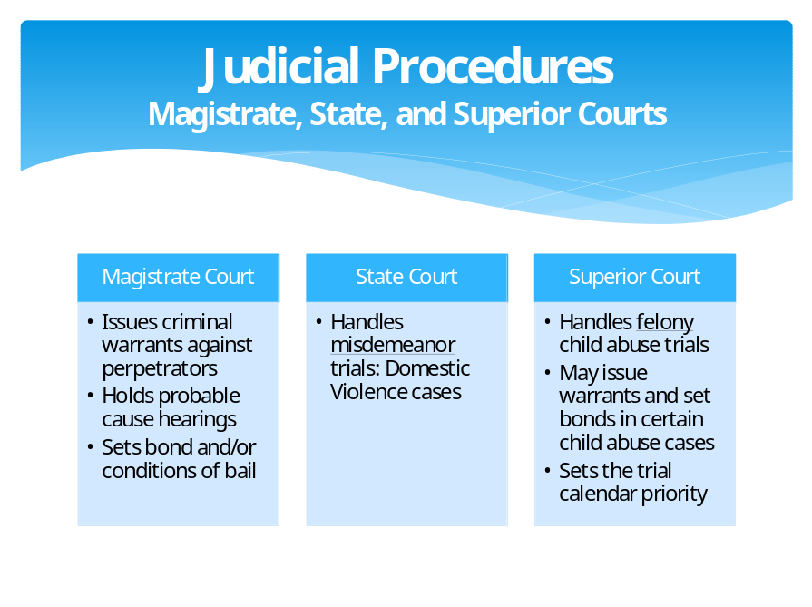
Court intervention does not always result in a removal of a child or a conviction of a crime. Removal is one option of several and these decisions should not be made lightly as the removal of a child from his or her parents can create significant and long-lasting negative impacts on a child. When an investigation of child abuse results in pursuing criminal and/or civil proceedings, the joint investigative efforts will be useful since much of what is learned during the investigative phase is relevant and necessary to the prosecution phase.

The superior court, state court, and magistrate court in (insert county/circuit) are responsible for criminal proceedings related to child abuse. Contact information for the superior court is (insert appropriate contact information here). Contact information for the state court is (insert appropriate contact information here). Contact information for the magistrate court is (insert appropriate contact information here).
- The courts will create a trauma-informed and trauma-responsive environment.
- The courts will adhere to all laws, including those related to child testimony, with a focus on minimizing additional trauma to the child when feasible, such that proceedings are conducted in a manner which is protective of the child and absent of perpetrator intimidation, consistent with the defendant’s constitutional rights. Note that it is unnecessary for a child abuse victim to appear at a magistrate court probable cause hearing as hearsay is allowed at this hearing.
- The courts will give priority to child abuse cases on the trial calendar, and otherwise schedule cases timely and in accordance with the law, minimizing the number of continuances granted and only grant continuances in accordance with the law and for the shortest time possible.
- The courts will consider all circumstances, paying particular attention to the child’s safety when setting bail and bail conditions. The court will consider the potential for further abuse to the child occurring if the accused is released on bond, and the seriousness of the offense in determining the amount of the bond being set. Any conditional bond request should be made by law enforcement at the time the warrant is requested. Restrictive conditions of bond including but not limited to an order to have no contact with the alleged child victim or any other child prior to finalization of the case may be considered. Any and all bond conditions will be communicated to DFCS and the juvenile court.
- The courts will ensure that a child who has been abused has a victim advocate to provide support and information throughout the duration of the proceedings. The court and the victim advocate will ensure the victim is familiar with the Crime Victims’ Bill of Rights and that all parties adhere to these laws.
- The courts will ensure the child and perpetrator receive appropriate treatment in response to abuse.
- Sentencing will reflect the need to protect the victim from the perpetrator.
- (Insert additional procedures for the superior, state, and magistrate courts to adhere to when responding to child abuse cases.)
The district attorney’s office will prosecute criminal cases of child abuse. Contact information for the district attorney is (insert appropriate contact information here).
- The district attorney and staff will coordinate with law enforcement and DFCS during the course of the investigation and preparing a case for criminal prosecution, including offering advice as to the preparation and execution of search warrants, logistics, and substance of suspect and witness interviews. The district attorney will communicate with others to further support and ensure a well-organized investigation.
- The district attorney and staff will be trauma-informed and trauma-responsive.
- The district attorney and staff will ensure the victim is appointed a victim advocate and receives any necessary and appropriate services through the victim advocate program.
- The district attorney and victim advocate will provide or facilitate a courtroom orientation with a child victim prior to that child being called to testify at trial.
- The district attorney and staff will strive to limit the child’s court appearances and need to testify; however, it cannot always be prevented. Regardless, the district attorney and staff will keep the child’s emotional well-being a high priority issue throughout the entire process. In the event it is necessary for the child to testify at trial, the district attorney will ensure any necessary and appropriate accommodations or arrangements are in place to minimize the potential trauma to the child.
- The district attorney and staff will discuss any plans for disposition, whether by trial or plea negotiations, with the victim’s guardian and/or the victim prior to disposition. The input of the victim and/or the victim’s guardian will be noted in the file and taken into consideration during the decision-making process.
- The district attorney and staff will notify DFCS and the SAAG of all case dispositions.
- (Insert additional procedures for the district attorney to adhere to when responding to child abuse cases.)
The juvenile court in (insert county/circuit) is responsible for civil proceedings related to dependency, delinquency, and Children in Need of Services (CHINS) cases and has the ability to authorize a child’s removal from his or her parents. Contact information for the juvenile court is (insert appropriate contact information here).
- The juvenile court will create a trauma-informed and trauma-responsive environment.
- The juvenile court will consistently consider and evaluate the child’s best interest in accordance with O.C.G.A. § 15-11-26.
- The juvenile court will adhere to laws related to child testimony, with a focus on minimizing additional trauma to the child when feasible.
- The juvenile court will schedule cases timely and in accordance with the law, minimizing the number of continuances granted and only grant continuances in accordance with the law and for the shortest time possible. The juvenile court will take into account the child’s daily routine and schedule hearings at times that will be as minimally disruptive to the child as possible; this will require consulting with the child and/or child’s caregiver to determine what schedule works best for the child.
- The juvenile court will ensure the child is appointed an attorney and guardian ad litem at the earliest possible stage and throughout the duration of the dependency proceedings.
- The juvenile court will consider the use of protective orders and temporary alternatives to foster care when appropriate in an effort to minimize trauma to the child.
- The juvenile court will ensure the child and family receive appropriate treatment in response to child abuse.
- (Insert additional procedures for the juvenile court to adhere to when responding to child abuse cases.)
(Insert county/counties) DFCS is responsible for responding to and investigating reports of child abuse. Contact information for (insert county/counties) DFCS is (insert appropriate contact information). When DFCS petitions the juvenile court for custody of a child, DFCS, represented by their attorney (referred to as a Special Assistant Attorney General (SAAG)), will “prosecute” civil cases of abuse in juvenile court. The SAAG(s) for (insert county/counties) DFCS is/are (insert name(s) of SAAG(s)) and the contact information for the SAAG(s) is (insert appropriate contact information).
- DFCS and the SAAG(s) will be trauma-informed and trauma-responsive.
- DFCS and the SAAG(s) will provide advance notice to witnesses who will be asked to testify during dependency proceedings.
- DFCS and the SAAG(s) will notify the District Attorney’s office of all related judicial proceedings involving the child victim.
- DFCS and the SAAG(s) will communicate and collaborate with protocol members to connect families to the appropriate agencies to receive services to address their safety, permanency, and well-being needs to ultimately achieve the best outcome for children and families.
Other protocol committee members involved in a case of child abuse will remain willing and available to participate in criminal and/or civil court proceedings as necessary.
(Insert additional specific court-related procedures)
(Insert additional specific procedures related to prosecution)

  - Additional Investigation and Prosecution Procedures by Topic

    - Family Violence (FV)
In addition to standard procedures, make every reasonable effort to:
- Determine whether children are or were present at the residence and obtain their name, age, demeanor, relationship to the parties and whether the child(ren) witnessed, heard or were physically harmed during the incident (intentionally or accidentally).
- Ask the parties where the child(ren) is/are and observe/interact with the child(ren).
- If the parties will not or are unable to answer as to the child(ren)’s welfare, and the officer has reason to believe a child(ren) is present by evidence of toys, clothes, etc. or other reason, follow law enforcement protocol for further search of the house.
Tips for talking with children at the scene:
➢ Address the child at eye level
➢ Explain your role in easy to understand terms
➢ Honor a child’s loyalty to an abusive parent
➢ Do not criticize or demean an abusive parent
➢ Acknowledge the child’s right not to speak
➢ Communicate your concern about the child’s safety
➢ Don’t make promises you can’t keep
➢ Discuss confidentiality and its limits

Source: Vermont’s 2004 Model Protocol as adapted from a handout developed by the Child Witness to Violence Project, Boston Medical Center (as contained in the 2015 Bryan/McIntosh County Protocol)
- If the child(ren) are found at the house, determine whether to seek protective custody and if so, contact the DFCS on-call case worker or director and make a report to DFCS’ CPS Intake Communication Center (CICC) so that DFCS can conduct a safety assessment.
- Make a referral or give the adult victim information on the nearest domestic violence shelter and otherwise discuss available services for him/her/their and the child(ren) if needed.
- Include the name of the child and date of birth in the incident reports.
- Try to separate children from the situation and where possible, avoid interviewing parties in the presence of the child or subduing or arresting someone in the child’s presence.
- Consider a forensic interview of the child.
(Insert additional procedures relevant when family violence is present.)
    - Physical Abuse
In addition to standard procedures, the following is relevant when physical abuse is present:
- Obtain medical treatment when needed.
- If medical treatment has previously been sought, obtain medical records and communicate with the medical provider(s).
- If there is a concern that a child’s injuries may have been sustained through non-accidental means, consult a medical provider who specializes in child abuse to obtain an expert medical opinion.
- If a medical provider suspects the child’s injuries are consistent with non-accidental trauma, ensure you understand and document their concerns and obtain medical explanations to clarify whether any alternative explanations as to how the child’s injuries were sustained are consistent or inconsistent with the medical provider’s examination of the child.
(Insert additional procedures relevant when physical abuse is present.)

    - Sexual Abuse
Children who may be victims of sexual abuse need to be assessed for their safety, taking into account the physical and/or psychological indications that may exist. Instances of sexual interaction between children should be reported to determine whether sexual abuse existed as part of the interaction and to determine whether either child has otherwise been a victim of sexual abuse to provide appropriate intervention.
- Law enforcement and DFCS will notify each other as soon as they are made aware of a potential victim of sexual abuse. If there is any suspicion that a child who has been sexually abused is also a victim of human trafficking, make a referral to the Children’s Advocacy Centers of Georgia (CACGA) for further assessment and also see the next section related to sexual exploitation.
- Law enforcement will properly gather evidence from various sources in the course of its investigation.
- Medical and forensic exams should be offered in most cases of sexual abuse, regardless of the length of time that may have elapsed between the most-recently reported sexual contact and the examination. Clinical providers will contact Children’s Healthcare of Atlanta (CHOA) at 404-785-7778 if a consultation is needed.
- Forensic medical examinations (FMEs) and sexual assault examinations can help to: 1) screen for injuries and medical conditions and initiate medical treatment; and 2) answer questions and reassure victims and parents about the child’s physical well-being; and 3) identify medical evidence to prosecute the offender(s).
  - Forensic medical examinations and sexual assault exams will be conducted using a trauma-informed, culturally sensitive, rights-based approach by (insert appropriate entity for the county/circuit).
  - Payment for these exams is available and supported through the Georgia Criminal Justice Coordinating Council (CJCC); victims should not be asked for payment.
  - Victim advocacy services during the exam process will be offered by (insert appropriate entity and include contact information).
  - The evidence collection kit will be sent to the GBI Crime Lab by (insert appropriate entity and include contact information).
  - A debrief with the doctor, nurse, or SANE who conducted the exam is an integral part of the investigation.
  - (Include any additional procedures relevant to forensic and sexual assault exams.)
(Insert additional procedures relevant when sexual abuse is present.)
    - Sexual Exploitation
Children who may be victims of sexual exploitation or human trafficking need to be assessed for their safety, taking into account the physical and/or psychological indications that may exist. In addition to standard procedures and the procedures related to sexual abuse, the following also apply in situations of sexual exploitation or human trafficking:
- All protocol members should familiarize themselves with the following:
  - Indicators/risk factors of sexual exploitation
  - Georgia’s Human Trafficking Notice
  - Georgia’s Human Trafficking Service Delivery Plan
  - Georgia’s Human Trafficking Service Delivery Protocol
If known, the following information will be helpful to provide to CACGA as part of the human trafficking referral:
➢ Youth information, including whether the youth is pregnant, parenting, or has a disability
➢ Family/household information
➢ Medical history
➢ Mental health, juvenile justice, or child welfare involvement
➢ Legal custodian(s) of youth and their information
➢ Reason for the referral along with any known prior history of exploitation, running away, homelessness, substance use, sexual abuse, or gang involvement
➢ Assessment scheduling preferences
➢ Whether a CANS assessment has previously been completed
➢ Copies of screening tools previously used or any other supporting documents
➢ Consent form and release of information
  - DFCS policies related to commercial sexual exploitation of children (CSEC) and trafficking, as well as DFCS’ Human Trafficking Case Management Statewide Protocol
  - DJJ policies related to commercial sexual exploitation referrals
  - CACGA’s contact information to refer suspected victims of human trafficking
  - GBI’s HEAT unit
  - The Human Trafficking Unit within the Georgia Attorney General’s office
- Law enforcement and DFCS will notify each other as soon as they are made aware of a potential victim of sexual exploitation or trafficking. Notification should also be provided to GBI’s Child Exploitation and Computer Crimes Unit.
- Refer individuals who are suspected to be victims of human trafficking to the CSEC Response Team of Children’s Advocacy Centers of Georgia (CACGA). The CSEC Response Team of CACGA will conduct a comprehensive assessment to include, but will not be limited to: the CSE-IT, a forensic interview, and a bio-psycho-social evaluation. Confirmation status will be provided and when appropriate, recommendations will be made to refer a child for additional evaluations and services.
- A request by law enforcement for DFCS or others not to make contact with the child’s parents for the safety of the child should be respected. Revealing confidential law enforcement investigatory information to potential suspects could easily place that child that has been recovered or other children that have yet to be recovered in danger. The Juvenile Court should be fully advised of this request when applying for a Shelter Care Order.
- Law enforcement will properly gather evidence from various sources in the course of its investigation.
- The statewide CSEC multi-disciplinary team, led by Children’s Healthcare of Atlanta (CHOA) and CACGA’s CSEC Response Team, will be available to provide assistance as needed.
- A forensic interview will be conducted consistent with the procedures previously outlined in the “Forensic Interview” section. The process for forensic interviews for children who have been sexually exploited may differ slightly from traditional forensic interviews. Effective information gathering requires that service providers and interviewers work to empower the child and help him or her understand their victimization. Trust should be established over time, and the formal forensic interview needs to occur after this trust has been established.
- If it is necessary for DFCS to seek custody of a child who has been sexually exploited or is otherwise a victim of human trafficking, DFCS will adhere to internal policies and procedures related to such victims, including ensuring a current photo of the child is on file, and also refer such victim to CACGA for assessment and further response/treatment if such a referral has not already been made.
- Even if a child is not in DFCS custody, a child may be referred to the CSEC Response Team and Receiving Hope Center for further assessment and short-term placement.
(Insert additional procedures relevant when sexual exploitation is present.)

    - Substance Use
Prenatal substance use. The state is required to develop a Plan of Safe Care (POSC) for families with infants identified as being affected by substance use, or withdrawal symptoms resulting from prenatal drug exposure or a Fetal Alcohol Spectrum Disorder (FASD). A POSC can be implemented with or without DFCS involvement at the outset or on an ongoing basis. The Plan of Safe Care is a process that involves multi-agency partnership with families to develop a written plan that ensures the safety and well-being of infants following release from the care of healthcare providers and addresses the health and substance use treatment needs of the infant and parent/caregiver and the needs of the other family members affected by the substance use. The Plan of Safe Care will be monitored to ensure referrals are made and appropriate services are delivered to the affected infant, family, or caregiver.
When encountering prenatal substance use and developing a Plan of Safe Care, the following information contributes to a comprehensive plan and should be shared amongst all those responding to and intervening in such situations:
- Current medical condition of the infant and mother;
- Written detail regarding substance(s) used (includes prescribed or non-prescribed substances);
- Level of substance in the mother and/or child’s system and whether the mother was receiving medication-assisted treatment (MAT) for a substance use disorder;
- Impact of the substance on the infant, including descriptions of withdrawal symptoms;
- Anticipated date of discharge; and
- Necessary medical follow-up that will be required for the care of the infant (e.g. heart or apnea monitors).
When allegations of prenatal abuse exist, DFCS will need to interview the parent and observe the infant; determine the level of extended family support which might reduce risk to the child; assess the mother’s acceptance and responsibility for the situation and her willingness to accept treatment for substance use related problems; refer the mother, child, and family to appropriate prevention or intervention providers; and seek court intervention when necessary.
(Insert additional procedures relevant to prenatal substance use.)
Postnatal substance use. A parent’s substance use on its own does not constitute child abuse; there must be a correlation between the parent’s substance use and its interference with the parent’s ability to appropriately care for the child(ren). To this end, evidence of substance use and the impact on the child(ren) will be necessary for related court proceedings. In the event that court intervention is sought, stakeholders should consider whether it is appropriate for the parent to participate in family dependency treatment court.
(Insert additional procedures relevant to postnatal substance use.)
    - Mental Health
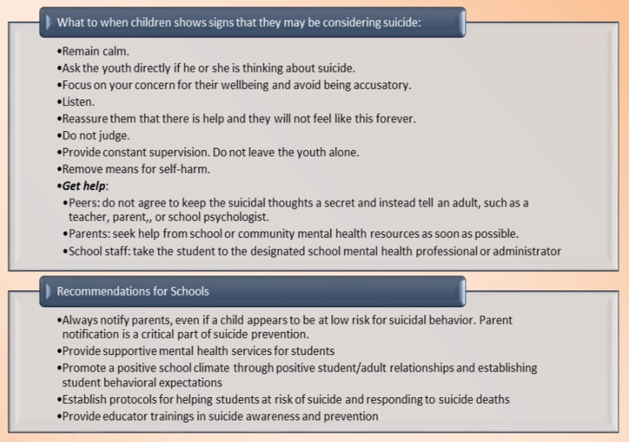
Mental health needs may be applicable to children or adults. Children should not enter foster care solely to receive mental health or behavioral health services. Instead, protocol committee members will work together, and in conjunction with the local interagency planning team (LIPT) as necessary, to support access to appropriate services and resources in an effort to maintain a child in his or her home when it is otherwise safe to do so. In addition to standard procedures, the following also apply when mental health concerns are present:
- Mental health needs of a child or an adult may constitute a disability under Title II of the ADA and Section 504 of the Rehabilitation Act of 1973. Ensure all responses are consistent with these laws.
- Contact the Georgia Crisis and Access Line (GCAL) when necessary. For immediate access to routine or crisis services, call 1-800-715-4225.
- Ensure all protocol committee agencies are educated about suicide prevention. Suicide prevention, intervention and aftercare education, information, resources, and PSAs are available through Georgia’s Department of Behavioral Health and Developmental Disabilities (DBHDD), the Georgia Suicide Prevention Action Network (SPAN-GA), and the Georgia Bureau of Investigation’s Child Fatality Review.
Source: Georgia Action Plan for Child Injury Prevention (2015) found here: https://gbi.georgia.gov/document/publication/georgia-action-plan-child-injury-preventionpdf/download
- (Insert information related to local Community Service Boards (CSBs))
(Insert additional procedures related to mental health concerns)
    - Child Death, Near Fatalities, and Serious Injuries
When a child dies, suffers a near fatality, or serious injury, the following needs to occur:
- All first responders will gather information that may be pertinent to the incident. This information will be provided to law enforcement and DFCS to inform the investigation and further response to these incidents. Appropriate information includes, but is not limited to: the circumstances surrounding the incident; the protective capacity of the caregiver; the condition of the caregiver at the time of the incident; possible contributing factors to the incident, such as substance use, smoking, and/or medical history of the child; and the sleep environment of the child if the incident was sleep-related.
- Notification to other protocol members as appropriate to further coordinate investigation efforts, i.e. to DECAL if the child’s death, near fatality, or serious injury occurred in a child care program.
- Engagement with relevant collaterals to obtain or verify information as appropriate.
- A re-enactment of the incident, using a re-enactment doll with the suspect and/or witness(es). Any re-enactment should be video recorded, if possible.
- Coordination with the Coroner or Medical Examiner’s Office to arrange an autopsy of the child, when warranted. All pertinent information needs to be shared with the Coroner or Medical Examiner’s Office. Law enforcement should attend the autopsy and obtain photographs from the autopsy.
- Law enforcement needs to obtain crime lab reports (e.g., autopsy, toxicology, blood alcohol, etc.) and share this information as appropriate.
- All agencies should complete any relevant forms related to internal or external procedures related to child death, near fatalities, and serious injuries.
- The incident will be reviewed as part of the local Child Fatality Review.
- This protocol committee will work with the (insert county/circuit name) Child Fatality Review to identify trends and implement prevention efforts.
- (Insert additional procedures related to child deaths, near fatalities, and serious injuries to be utilized in the local protocol.)

- Methods to be used in coordinating treatment programs for the child, the family, and the perpetrator
The goal of treatment is to facilitate healing. Therapy can help children (and parents):
- Learn about trauma and child sexual abuse as well as healthy sexuality
- Develop effective coping and body safety skills
- Overcome problematic thoughts, feelings, and behaviors
- Therapeutically process traumatic memories
Providing therapeutic interventions for children who have been abused requires: 1) an understanding of normal child development and the processes of abnormal development or psychopathology as well as an ability to assess the severity and types of behavioral, emotional, developmental, and psychological problems that children who have been abused may present; 2) familiarity with the major issues common to children who have been abused; and 3) the skills necessary to manage these types of cases. Providing treatment to children who have been abused is a significant undertaking requiring clinical training and education.
The primary involved agency will coordinate referrals for evaluation, assessment, treatment and counseling. If appropriate, the referring agency will complete demographic information and release of information forms needed by the provider. The Multi-Disciplinary Team (MDT) may assist in determining if there is a need of referral for treatment and treatment providers may participate in the MDT and/or the Local Interagency Planning Team (LIPT) to discuss findings and recommendations.
For physical abuse, sexual abuse, and neglect cases, the following are resources in (insert County/Circuit) that may provide treatment:
- (Insert the name of the local Child Advocacy Center (CAC))
- (Insert the name of the local Sexual Assault Center (SAC), if different from the CAC)
- (Insert any additional trained child therapists at local agencies that may provide treatment)
- (Insert any local behavioral health providers known to have experience and expertise with child sexual and/or physical abuse)
- (Insert any additional treatment resources)
For sexual exploitation and human trafficking cases, contact the Child Advocacy Centers of Georgia (CACGA) at 1-866-END-HTGA (1-866-363-4842) to assist in the assessment and identification of appropriate services and resources. (Insert additional, relevant specific procedures and contact information as appropriate.)
For Superior Court cases, Adult Probation and Parole will coordinate referrals for perpetrator treatment by state licensed clinicians. For Juvenile Court cases, DJJ will do the same. (Insert additional, relevant specific procedures and contact information as appropriate.)
(Insert any additional methods to be used in coordinating treatment programs for the child, the family, or the perpetrator here.)
(Insert any additional, relevant local resources that may provide therapeutic interventions here or as an appendix.)

- Additional Considerations
Secondary traumatic stress, vicarious trauma, compassion fatigue, and burnout. It is important to recognize that professionals encountering child abuse as a nature of their work frequently experience emotional stress including Secondary Traumatic Stress (STS), vicarious trauma, compassion fatigue, or burnout. STS cannot be prevented since it is a normal human and universal response to helping victims of abnormal events such as violence and/or disasters, but negative STS effects can be prevented from developing into a more serious condition. Management of STS and similar emotional stresses is essential to mitigating its negative impact and individual coping skills can be developed that can assist in the management of these stressors and symptoms. Increasing awareness of STS as a normal part of child protection and welfare work, STS symptoms and risk factors, and protective factors and self-care strategies can help to mitigate the effects of STS. This awareness may serve to improve the work performance and retention of such professionals and reduce the stress-induced physical and mental health problems that may result from STS. All committee members should be educated about STS and similar stresses, recognizing that we each have our own adverse childhood experiences (ACEs) that may exacerbate some of the STS encountered. All committee members should also show each other and themselves compassion, understanding, and support to mitigate the effects of these stresses and build worker resiliency.

(Insert any additional considerations here.)

- Resources
(Identify and include local, state, and national resources useful to the goals of this protocol. Communities may have a resource guide that could be included here or as an appendix. Refer to Appendix D - Local, State, and National Resources for a checklist to use as a planning tool for this section.)

- Understanding and Agreement
The foregoing document reflects a cooperative effort on the part of (insert county/circuit name) social services, mental health, education, and criminal justice organizations to continue to improve and refine their response to cases of child abuse in (insert county/circuit name).
The undersigned agency, department and judicial representatives commit themselves and their organizations to the implementation of the procedures as outlined in this protocol. It is understood that the adoption of this protocol is an ongoing process of cooperation and coordination to facilitate the effective handling of child abuse cases in (insert county/circuit name) in such a way as to minimize trauma to the child and obtain effective remedies to prevent further abuse.
The protocol is not intended to, does not, and may not be relied upon to create any rights, substantive or procedural, enforceable at law by any party in any matter civil or criminal. The protocol shall not limit or otherwise restrict a prosecuting attorney in the exercise of his or her discretion nor in the exercise of any otherwise lawful litigative prerogatives. The law controls the provisions of the Protocol.
The signatories to this protocol are committed to continuing as an interagency committee as required by law and to periodically review and refine this interagency protocol for effectively preventing and responding to child abuse in (insert county/circuit name). In so doing, the protocol committee will identify critical issues, needs and resources required to facilitate and enhance the prevention, investigation, prosecution, and treatment of child abuse in (insert county/circuit name).
The protocol committee will meet at least semiannually for the purpose of evaluating the effectiveness of the protocol and appropriately modifying and updating the same and for the purpose of preparing and issuing its annual report required by law.

- Signatures
(Insert signature blocks for all member agency representatives to sign and date.)

- Appendices

- O.C.G.A. § 19-15-2 (Child Abuse Protocol Governing Legislation)
- O.C.G.A. § 15-11-26 (Best Interest of the Child Factors)
- Sample Annual Report
- Local, State, and National Resources
- Child Developmental Stages and Milestones
- Prevention-Focused Protective Factors and Efforts
- Potential Indicators of Abuse
- DFCS Mandated Reporter Form
- Additional Information Regarding Forensic Interviews and Evaluations
- Children’s Advocacy Centers of Georgia CSEC Response Team
- Investigating Child Homicide Factsheet
- (Insert additional appendices as needed)

APPENDIX A: O.C.G.A. § 19-15-2

(Child Abuse Protocol Governing Legislation)

§ 19-15-2. Protocol committee on child abuse; written protocol; training of members; written sexual abuse and exploitation protocol
- Except as provided in paragraph (3) of subsection (b) of this Code section, each county shall be required to establish a protocol for the investigation and prosecution of alleged cases of child abuse as provided in this Code section.

(b)
(1) The chief superior court judge of the circuit in which the county is located shall establish a protocol committee as provided in subsection (c) of this Code section and shall appoint an interim chairperson who shall preside over the first meeting, and the chief superior court judge shall appoint persons to fill any vacancies on the protocol committee.
(2) After the establishment of a protocol committee, the committee members shall elect a chairperson from the protocol committee's membership. The protocol committee shall be charged with developing local protocols for the investigation and prosecution of alleged cases of child abuse.
(3) When a judicial circuit is composed of more than one county, the protocol committee shall determine if it shall be established for each county in the judicial circuit or if it will serve all of the counties within the judicial circuit.

(c) (1) Each of the following individuals, agencies, and entities shall designate a representative to serve on a protocol committee established pursuant to paragraph (1) of subsection (b) of this Code section:
(A) The sheriff;
(B) The county department of family and children services;
(C) The district attorney for the judicial circuit;
(D) The presiding juvenile court judge;
(E) The chief magistrate;
(F) The county board of education;
(G) The county mental health organization;
(H) The chief of police of a county in counties which have a county police department;
(I) The chief of police of the largest municipality in the county;
(J) The county public health department; and
(K) The coroner or county medical examiner.
(2) Each of the following individuals, agencies, and entities shall designate a representative to serve on a protocol committee established pursuant to paragraph (3) of subsection (b) of this Code section:
(A) The sheriff of each county in the judicial circuit;
(B) The county department of family and children services of each county in the judicial circuit;
(C) The district attorney for the judicial circuit;
(D) The presiding juvenile court judge of each county in the judicial circuit;
(E) The chief magistrate of each county in the judicial circuit;
(F) Each board of education in the judicial circuit;
(G) The county mental health organization of each county in the judicial circuit;
(H) The chief of police of each county in the judicial circuit, if any;
(I) The chief of police of the largest municipality in the judicial circuit;
(J) The county public health department of each county in the judicial circuit; and
(K) The coroner or county medical examiner of each county in the judicial circuit.
(3) A representative of a local child advocacy center shall serve on a protocol committee established under paragraph (1) or (3) of subsection (b) of this Code section if one exists in such location.
(4) A representative of a sexual assault center shall serve on a protocol committee established under paragraph (1) or (3) of subsection (b) of this Code section if one exists in such location.
(5) In addition to the representatives serving on the protocol committee as provided for in paragraphs (1) through (4) of this subsection, the chief superior court judge shall designate a representative from a local citizen or advocacy group which focuses on child abuse awareness and prevention to serve on such protocol committee.
(6) If any designated agency fails to carry out its duties relating to participation on the protocol committee, the chief superior court judge of the circuit may issue an order requiring the participation of such agency. Failure to comply with such order shall be cause for punishment as for contempt of court.

(d) Each protocol committee chairperson shall be responsible for ensuring that written protocol procedures are followed by all agencies. Such person may be independent of agencies listed in paragraph (1) of subsection (c) of this Code section. The protocol committee may appoint such additional members as necessary and proper to accomplish the purposes of the protocol committee.

(e) The protocol committee shall adopt a written protocol which shall be filed with the Division of Family and Children Services of the Department of Human Services and the Office of the Child Advocate for the Protection of Children, a copy of which shall be furnished to each agency in the county handling the cases of abused children. The protocol shall be a written document outlining in detail the procedures to be used in investigating and prosecuting cases arising from alleged child abuse and the methods to be used in coordinating treatment programs for the perpetrator, the family, and the child. The protocol shall also outline procedures to be used when child abuse occurs in a household where there is violence between past or present spouses, persons who are parents of the same child, parents and children, stepparents and stepchildren, foster parents and foster children, or other persons living or formerly living in the same household. The protocol adopted shall not be inconsistent with the policies and procedures of the Division of Family and Children Services of the Department of Human Services.

(f) The purpose of the protocol shall be to ensure coordination and cooperation between all agencies involved in a child abuse case so as to increase the efficiency of all agencies handling such cases, to minimize the stress created for the allegedly abused child by the legal and investigatory process, and to ensure that more effective treatment is provided for the perpetrator, the family, and the child, including counseling.

(g) Upon completion of the writing of the protocol, the protocol committee shall continue in existence and shall meet at least semiannually for the purpose of evaluating the effectiveness of the protocol and appropriately modifying and updating the same. The protocol committee shall file the updated protocol with the Division of Family and Children Services of the Department of Human Services and the Office of the Child Advocate for the Protection of Children not later than the first day of September each year.

(h) Each protocol committee shall adopt or amend its written protocol to specify the circumstances under which law enforcement officers shall and shall not be required to accompany investigators from the county department of family and children services when these investigators investigate reports of child abuse. In determining when law enforcement officers shall and shall not accompany investigators, the protocol committee shall consider the need to protect the alleged victim and the need to preserve the confidentiality of the report. Each protocol committee shall establish joint work efforts between the law enforcement and investigative agencies in child abuse investigations. The adoption or amendment of the protocol shall also describe measures which can be taken within the county or circuit, as the case may be, to prevent child abuse and shall be filed with and furnished to the same entities with or to which an original protocol is required to be filed or furnished. The protocol shall be further amended to specify procedures to be adopted by the protocol committee to ensure that written protocol procedures are followed.

(i) The protocol committee shall issue a report no later than the first day of July each year. Such report shall evaluate the extent to which investigations of child abuse during the 12 months prior to the report have complied with the protocols of the protocol committee, recommend measures to improve compliance, and describe which measures taken within the county or circuit, as the case may be, to prevent child abuse have been successful. The report shall be transmitted to the county governing authority, the fall term grand jury of the judicial circuit, the Office of the Child Advocate for the Protection of Children, and the chief superior court judge of the circuit.

(j) Each member of each protocol committee shall receive appropriate training within 12 months after his or her appointment. The Office of the Child Advocate for the Protection of Children shall provide such training.
(k) The protocol committee shall include a written sexual abuse and sexual exploitation section within its protocol which shall be filed with the Division of Family and Children Services of the Department of Human Services and the Office of the Child Advocate for the Protection of Children, a copy of which shall be furnished to each agency in the county handling the cases of sexually abused or exploited children. The sexual abuse and sexual exploitation section of the protocol shall outline in detail the procedures to be used in investigating and prosecuting cases arising from alleged sexual abuse and sexual exploitation and the procedures to be followed concerning the obtainment of and payment for sexual assault examinations. The sexual abuse and sexual exploitation section of the protocol shall be consistent with the policies and procedures of the Division of Family and Children Services of the Department of Human Services. The sexual abuse and sexual exploitation section of the protocol is not intended to, does not, and may not be relied upon to create any rights, substantive or procedural, enforceable at law by any party in any matter civil or criminal. Such section of the protocol shall not limit or otherwise restrict a prosecuting attorney in the exercise of his or her discretion nor in the exercise of any otherwise lawful litigative prerogatives.

APPENDIX B: O.C.G.A. § 15-11-26

(Best Interest of the Child Factors)

§ 15-11-26. Best interests of child
Whenever a best interests determination is required, the court shall consider and evaluate all of the factors affecting the best interests of the child in the context of such child's age and developmental needs. Such factors shall include:

(1) The physical safety and welfare of such child, including food, shelter, health, and clothing;

(2) The love, affection, bonding, and emotional ties existing between such child and each parent or person available to care for such child;

(3) The love, affection, bonding, and emotional ties existing between such child and his or her siblings, half siblings, and stepsiblings and the residence of such other children;

(4) Such child's need for permanence, including such child's need for stability and continuity of relationships with his or her parent, siblings, other relatives, and any other person who has provided significant care to such child;

(5) Such child's sense of attachments, including his or her sense of security and familiarity, and continuity of affection for such child;

(6) The capacity and disposition of each parent or person available to care for such child to give him or her love, affection, and guidance and to continue the education and rearing of such child;

(7) The home environment of each parent or person available to care for such child considering the promotion of such child's nurturance and safety rather than superficial or material factors;

(8) The stability of the family unit and the presence or absence of support systems within the community to benefit such child;

(9) The mental and physical health of all individuals involved;

(10) The home, school, and community record and history of such child, as well as any health or educational special needs of such child;

(11) Such child's community ties, including church, school, and friends;

(12) Such child's background and ties, including familial, cultural, and religious;

(13) The least disruptive placement alternative for such child;

(14) The uniqueness of every family and child;

(15) The risks attendant to entering and being in substitute care;

(16) Such child's wishes and long-term goals;

(17) The preferences of the persons available to care for such child;

(18) Any evidence of family violence, substance abuse, criminal history, or sexual, mental, or physical child abuse in any current, past, or considered home for such child;

(19) Any recommendation by a court appointed custody evaluator or guardian ad litem; and

(20) Any other factors considered by the court to be relevant and proper to its determination.

APPENDIX C: Sample Annual Report
PROTOCOL COMMITTEE - ANNUAL REPORT

County/Counties: Judicial Circuit:

Date of Submission: (Pursuant to O.C.G.A. § 19-15-2(i) the protocol committee is issuing this annual report no later than the first day of July.)

1. (Evaluate the extent to which the child abuse investigations during the 12 months prior to the report have complied with the child abuse protocol):

2. (Recommend measure(s) to improve compliance):

3. (Describe which measures taken within the county to prevent child abuse have been successful):

Activities/Concerns:

______________________________
Chair - Printed Name and Title

Address:

Phone:

Email:

The report shall be submitted to the:
1. County governing authority
2. Fall term grand jury of the judicial circuit
3. Office of the Child Advocate, 7 Martin Luther King, Jr. Drive, Suite 347, Atlanta, GA 30334
4. Chief superior court judge
APPENDIX D: Local, State, and National Resources
Local, state and national resources listed below promote the general welfare of children and families, provide prevention activities to children, families and the community, provide prevention of the recurrence of abuse and neglect, and support the work of CAP committees.
Local Resources:
(Insert Name and Contact Information for Local Multi-Disciplinary Team (MDT))
(Insert Name and Contact Information for Local Interagency Planning Team (LIPT)
(Insert Name and Contact Information for Local Child Fatality Review (CFR))
(Insert Name and Contact Information for the County Sheriff’s Department(s))
(Insert Name and Contact Information for all Police Departments within the jurisdiction of this protocol)
(Insert Name and Contact Information for the County DFCS Office(s))
(Insert Name and Contact Information for the County District Attorney(s))
(Insert Name and Contact Information for the County Solicitor General(s))
(Insert Name and Contact Information for the County Public Defender’s Office(s))
(Insert Name and Contact Information for the County Coroner(s))
(Insert Name and Contact Information for the County Medical Examiner(s))
(Insert Name and Contact Information the County Board(s) of Education)
(Insert Name and Contact Information for the Local Court Appointed Special Advocate (CASA) Program(s))
(Insert Name and Contact Information for the County Special Assistant Attorney General(s) (SAAGs))
(Insert Name and Contact Information for the County Juvenile Court(s))
(Insert Name and Contact Information for the County Superior Court(s))
(Insert Name and Contact Information for the County Magistrate Court(s))
(Insert Name and Contact Information for the County Probate Court(s))
(Insert Name and Contact Information for the County Health Department(s))
(Insert Name and Contact Information for the Local Hospital(s))
(Insert Name and Contact Information for the Local Child Advocacy Center(s))
(Insert Name and Contact Information for the Local Sexual Assault Center(s))
(Insert Name and Contact Information for the Local Mental Health Organization(s))
(Insert Name and Contact Information for additional local resources, which may include but are not limited to the following:
- Programs available through any entity that participates in this protocol
- A child-friendly interview room or visitation center
- A Family Treatment Court or other relevant Accountability Court
- Substance use prevention and intervention programs
- Early childhood education centers and programs, including pre-kindergarten and Head Start programs
- After-school and summer programs for children
- Alternative learning school(s)
- An umbrella agency which plans, coordinates, and evaluates needed children and family programs and services
- Family Connection Partnership program(s)
- Shelters for victims of domestic violence or intimate partner violence
- Homeless shelters or related resources
- A Child in Need of Services (CHINS) program
- Community-Based Risk Reduction Programs
- Community awareness information and events programs
- Parent education or support programs
- Housing Authority
- Home health nurse or visiting program
- Prevention-focused resources
- Rape prevention, education, and crisis lines
- School-based mental health services
- Therapy animal programs
- Social services available through hospitals, schools, and other community entities)

State Resources:
- 2-1-1/United Way
  - 2-1-1: http://211online.unitedwayatlanta.org/
  - United Ways in Georgia https://www.unitedway.org/local/united-states/georgia#

- Barton Child Law and Policy Center at Emory Law School
  - http://bartoncenter.net/

- Center of Excellence for Children’s Behavioral Health, Georgia Health Policy Center, Georgia State University
  - https://gacoeonline.gsu.edu/
  - 404-413-0075

- Children’s Advocacy Centers of Georgia (CACGA)
  - https://www.cacga.org/
  - State CAC Network: 770-319-6888;
  - Human Trafficking Concerns: 1-866-END-HTGA (842-4842)

- Children’s Healthcare of Atlanta, Stephanie V. Blank Center for Safe and Healthy Children
  - https://www.choa.org/medical-services/child-protection-advocacy-center

- Committee on Justice for Children, Judicial Council of Georgia/Administrative Office of the Courts
  - https://georgiacourts.gov/j4c/
  - 404-656-5171

- Georgia Bureau of Investigation (GBI):
  - https://gbi.georgia.gov/
  - 24 Hour Communications Center: 404-244-2600
  - Child Exploitation and Computer Crimes Unit: https://investigative-gbi.georgia.gov/investigative-offices-and-services/specialized-units/child-exploitation-and-computer-crimes-unit; 404-270-8870
  - Child Fatality Review: https://gbi.georgia.gov/CFR; 404-270-8715
  - Crisis Intervention Team: https://gbi.georgia.gov/divisions/crisis-intervention-team
  - Georgia Crime Information Center (GCIC) for attorneys requesting information for trial preparation: gcic.attorneys@gbi.state.ga.us; 404-244-2639
  - Sex Offender Registry: GCICSexOffenders@gbi.ga.gov; 404-270-8465

- Georgia Coalition Against Domestic Violence
  - https://gcadv.org
  - 404-209-0280

- Georgia Commission on Family Violence
  - https://gcfv.georgia.gov/
  - 404-657-3412
  - Hotline: 1-800-33-HAVEN (1-800-334-2836)

- Georgia Coroners Association
  - https://www.georgiacoronersassoc.org/

- Georgia Court Appointed Special Advocates (GA CASA)
  - https://www.gacasa.org/
  - 800-251-4012
  - info@gacasa.org

- Georgia Criminal Justice Coordinating Council (CJCC)
  - https://cjcc.georgia.gov/
  - 404-657-1956

- Georgia Department of Behavioral Health and Developmental Disabilities (DBHDD)
  - https://dbhdd.georgia.gov/
  - 404-657-2252
  - Georgia APEX Program (school-based mental health services and supports): https://dbhdd.georgia.gov/georgia-apex-program
  - Georgia Crisis and Access (GCAL) Line: 1-800-715-4225 (24/7)
  - Mental Health for Children, Young Adults, and Families: https://dbhdd.georgia.gov/be-dbhdd/be-supported/mental-health-children-young-adults-and-families

- Georgia Department of Community Affairs (DCA)
  - https://www.dca.ga.gov/
  - 404-679-4840

- Georgia Department of Community Health (DCH)
  - https://dch.georgia.gov/
  - 404-656-4507

- Georgia Department of Community Supervision
  - https://dcs.georgia.gov/
  - 678-783-4337

- Georgia Department of Early Care and Learning (DECAL), Bright from the Start
  - http://www.decal.ga.gov/
  - 404-656-5957
  - Childcare and Parent Services (CAPS) https://caps.decal.ga.gov/en/

- Georgia Department of Education (GaDOE)
  - https://www.gadoe.org/Pages/Home.aspx

- Georgia Department of Juvenile Justice (DJJ)
  - https://djj.georgia.gov/
  - 404-508-6500

- Georgia Department of Public Health (DPH)
  - https://dph.georgia.gov/
  - 404-657-2700
  - Babies Can’t Wait (Early identification, screening, and intervention for children 0-3 for developmental delays and certain health conditions): https://dph.georgia.gov/babies-cant-wait; 404-657-2850
  - Children 1st (Early intervention services for children 0-5 who may be at risk for poor health outcomes and developmental delays): https://dph.georgia.gov/children1st; 404-657-2850
  - Children’s Health: https://dph.georgia.gov/childrens-health; 404-657-2850
  - Women, Infants, and Children (WIC): https://dph.georgia.gov/WIC; 800-228-9173

- Georgia Division of Family and Children Services (DFCS)
  - www.dfcs.dhs.ga.gov
  - 1-855-GA-CHILD (1-855-422-4453)
  - Prevention and Community Support: https://dfcs.georgia.gov/services/prevention-and-community-support-section; gadfcs.prevention@dhs.ga.gov

- Georgia Early Education Alliance for Ready Students (GEEARS)
  - https://geears.org/
  - 404-410-8564

- Georgia Family Connection Partnership
  - https://gafcp.org/
  - 404-527-7394
- Georgia Legal Services Program
  - https://www.glsp.org/
  - 1-800-498-9469
  - Atlanta Legal Aid: https://atlantalegalaid.org/
  - Georgia Legal Aid https://www.georgialegalaid.org/

- Georgia Office of the Attorney General
  - https://law.georgia.gov/
  - 404-651-8600

- Georgia Office of the Child Advocate
  - www.oca.ga.gov
  - 404-656-4200

- Georgia Governor’s Office of Student Achievement (GOSA)
  - https://gosa.georgia.gov/

- Georgia Vocational Rehabilitation Agency
  - https://gvs.georgia.gov/

- Get Georgia Reading Campaign for Grade Level Reading
  - https://getgeorgiareading.org/
  - GGR@gafcp.org

- Healthy Mothers, Healthy Babies
  - https://www.resourcehouse.com/hmhb/
  - 1-800-300-9003
  - thecoalition@hmhbga.org
  - Georgia Family Health Line (Help with finding services/referrals for medical care; interpreters available in 170+ languages): 1-800-300-9003

- Prevent Child Abuse Georgia (PCA GA)
  - https://abuse.publichealth.gsu.edu/
  - 404-413-1296
  - 1-800-CHILDREN (1-800-244-5373)

- Prosecuting Attorneys’ Council of Georgia
  - https://pacga.org/
  - 770-282-6300
  - info@pacga.org

- Technical College System of Georgia (TCSG)
  - https://www.tcsg.edu/

- Together Georgia
  - https://togetherga.net/
  - 404-572-6170
  - office@togetherga.net

- University System of Georgia (USG)
  - https://www.usg.edu/

- Voices for Georgia’s Children
  - https://georgiavoices.org/

National Resources:
- American Academy of Pediatrics
  - www.aap.org
  - 800-433-9016

- American Bar Association (ABA) Center on Children and the Law
  - https://www.americanbar.org/groups/public_interest/child_law/

- American Professional Society on the Abuse of Children (APSAC)
  - https://www.apsac.org/
  - 877-402-7722

- Capacity Building Center for States
  - https://capacity.childwelfare.gov/states/

- Centers for Disease Control (CDC)
  - https://www.cdc.gov/
  - Child Abuse and Neglect Prevention: https://www.cdc.gov/violenceprevention/childabuseandneglect/index.html?CDC_AA_refVal=https%3A%2F%2Fwww.cdc.gov%2Fviolenceprevention%2Fchildmaltreatment%2Findex.html

- Center for the Study of Social Policy
  - https://cssp.org/

- Child Welfare Information Gateway
  - https://www.childwelfare.gov/

- Children’s Bureau, an Office of the Administration for Children and Families (ACF)
  - https://www.acf.hhs.gov/cb

- Children’s Defense Fund (CDF)
  - https://www.childrensdefense.org/

- FRIENDS National Resource Center for Community-Based Child Abuse Prevention (CBCAP)
  - https://friendsnrc.org/

- National Association of Counsel for Children (NACC)
  - https://www.naccchildlaw.org/

- National Association for Education of Young Children (NAEYC)
  - https://www.naeyc.org/

- National Center for Children in Poverty
  - https://www.nccp.org/

- National Center for Missing and Exploited Children (NCMEC)
  - https://www.missingkids.org/HOME
  - 1-800-THE-LOST (1-800-843-5678)

- National Center on Shaken Baby Syndrome
  - https://www.dontshake.org/
  - 801-447-9360
  - mail@dontshake.org

- National CASA/GAL Association
  - https://nationalcasagal.org/
  - 800-628-3233

- National Children’s Advocacy Center
  - https://www.nationalcac.org/
  - 256-533-KIDS (5437)

- National Children’s Alliance
  - https://www.nationalchildrensalliance.org/

- National Council on Child Abuse and Family Violence (NCCAFV)
  - https://www.preventfamilyviolence.org/
  - 202-857-9778

- National Council of Juvenile and Family Court Judges (NCJFCJ)
  - https://www.ncjfcj.org/

- National Domestic Violence Hotline
  - https://www.thehotline.org/
  - 1-800-799-SAFE (1-800-799-7233)

- National Fatherhood Initiative (NFI)
  - https://www.fatherhood.org/

- National Institute of Health
  - https://www.nih.gov/
  - National Safe to Sleep Public Education Campaign: https://safetosleep.nichd.nih.gov/

- Polaris Project
  - https://polarisproject.org/

- Prevent Child Abuse America
  - https://preventchildabuse.org/

- Prevention Institute
  - https://www.preventioninstitute.org/

- Rape, Abuse, and Incest National Network (RAINN)
  - https://www.rainn.org/

- Zero to Three
  - https://www.zerotothree.org/

APPENDIX E: Child Developmental Stages and Milestones
What most babies do by 2 months old:
- Social/Emotional
  - Begins to smile at people
  - Can briefly calm himself (may bring hands to mouth and suck on hand)
  - Tries to look at parent
- Language/Communication
  - Coos, makes gurgling sounds
  - Turns head toward sounds
- Cognitive (learning, thinking, problem-solving)
  - Pays attention to faces
  - Begins to follow things with eyes and recognize people at a distance
  - Begins to act bored (cries, fussy) if activity doesn’t change
- Movement/Physical Development
  - Can hold head up and begins to push up when lying on tummy
  - Makes smoother movements with arms and legs

What most babies do by 4 months old:
- Social/Emotional
  - Smiles spontaneously, especially at people
  - Likes to play with people and might cry when playing stops
  - Copies some movements and facial expressions, like smiling or frowning
- Language/Communication
  - Begins to babble
  - Babbles with expression and copies sounds he hears
  - Cries in different ways to show hunger, pain, or being tired
- Cognitive (learning, thinking, problem-solving)
  - Lets you know if she is happy or sad
  - Responds to affection
  - Reaches for toy with one hand
  - Uses hands and eyes together, such as seeing a toy and reaching for it
  - Follows moving things with eyes from side to side
  - Watches faces closely
  - Recognizes familiar people and things at a distance
- Movement/Physical Development
  - Holds head steady, unsupported
  - Pushes down on legs when feet are on a hard surface
  - May be able to roll over from tummy to back
  - Can hold a toy and shake it and swing at dangling toys
  - Brings hands to mouth
  - When lying on stomach, pushes up to elbows

What most babies do by 6 months old:
- Social/Emotional
  - Knows familiar faces and begins to know if someone is a stranger
  - Likes to play with others, especially parents
  - Responds to other people’s emotions and often seems happy
  - Likes to look at self in a mirror
- Language/Communication
  - Responds to sounds by making sounds
  - Strings vowels together when babbling (“ah,” “eh,” “oh”) and likes taking turns with parent while making sounds
  - Responds to own name
  - Makes sounds to show joy and displeasure
  - Begins to say consonant sounds (jabbering with “m,” “b”)
- Cognitive (learning, thinking, problem-solving)
  - Looks around at things nearby
  - Brings things to mouth
  - Shows curiosity about things and tries to get things that are out of reach
  - Begins to pass things from one hand to another
- Movement/Physical Development
  - Rolls over in both directions (front to back, back to front)
  - Begins to sit without support
  - When standing, supports weight on legs and might bounce
  - Rocks back and forth, sometimes crawling backward before moving forward

What most babies do by 9 months old:
- Social/Emotional
  - May be afraid of strangers
  - May be clingy with familiar adults
  - Has favorite toys
- Language/Communication
  - Understands “no”
  - Makes a lot of different sounds like “mamamama” and “bababababa”
  - Copies sounds and gestures of others
  - Uses fingers to point at things
- Cognitive (learning, thinking, problem-solving)
  - Watches the path of something as it falls
  - Looks for things he sees you hid
  - Plays peek-a-boo
  - Puts things in her mouth
  - Moves things smoothly from one hand to the other
  - Picks up things like cereal o’s between thumb and index finger
- Movement/Physical Development
  - Stands, holding on
  - Can get into sitting position
  - Sits without support
  - Pulls to stand
  - Crawls
*At 9 months old, the AAP recommends a general developmental screening.
What most children do by 1 year old:
- Social/Emotional
  - Is shy or nervous with strangers
  - Cries when mom or dad leaves
  - Has favorite things and people
  - Shows fear in some situations
  - Hands you a book when he wants to hear a story
  - Repeats sounds or actions to get attention
  - Puts out arm or leg to help with dressing
  - Plays games such as “peek-a-boo” and “pat-a-cake”
- Language/Communication
  - Responds to simple spoken requests
  - Uses simple gestures, like shaking head “no” or waving “bye-bye”
  - Makes sounds with changes in tone (sounds more like speech)
  - Says “mama” and “dada” and exclamations like “uh-oh!”
  - Tries to say words you say
- Cognitive (learning, thinking, problem-solving)
  - Explores things in different ways, like shaking, banging, throwing
  - Finds hidden things easily
  - Looks at the right picture or thing when it’s named
  - Copies gestures
  - Starts to use things correctly; for example, drinks from a cup, brushes hair
  - Bangs two things together
  - Puts things in a container, takes things out of a container
  - Lets things go without help
  - Pokes with index (pointer) finger
  - Follows simple directions like “pick up the toy”
- Movement/Physical Development
  - Gets to a sitting position without help
  - Pulls up to stand, walks holding on to furniture (“cruising”)
  - May take a few steps without holding on
  - May stand alone
What most children do by 18 months old:
- Social/Emotional
  - Likes to hand things to others as play
  - May have temper tantrums
  - May be afraid of strangers
  - Shows affection to familiar people
  - Plays simple pretend, such as feeding a doll
  - May cling to caregivers in new situations
  - Points to show others something interesting
  - Explores alone but with parent close by
- Language/Communication
  - Says several single words
  - Says and shakes head “no”
  - Points to show someone what he wants
- Cognitive (learning, thinking, problem-solving)
  - Knows what ordinary things are for; for example, telephone, brush, spoon
  - Points to get the attention of others
  - Shows interest in a doll or stuffed animal by pretending to feed
  - Points to one body part
  - Scribbles on his own
  - Can follow 1-step verbal commands without any gestures; for example, sits when you say “sit down”
- Movement/Physical Development
  - Walks alone
  - May walk up steps and run
  - Pulls toys while walking
  - Can help undress herself
  - Drinks from a cup
  - Eats with a spoon
*At 18 months old, the AAP recommends a general developmental screening and an autism screening.
What most children do by 2 years old:
- Social/Emotional
  - Copies others, especially adults and older children
  - Gets excited when with other children
  - Shows more and more independence
  - Shows defiant behavior (doing what he has been told not to)
  - Plays mainly beside other children, but is beginning to include other children, such as in chase games
- Language/Communication
  - Points to things or pictures when they are named
  - Knows names of familiar people and body parts
  - Says sentences with 2 to 4 words
  - Follows simple instructions
  - Repeats words overheard in conversation
  - Points to things in a book
- Cognitive (learning, thinking, problem-solving)
  - Finds things even when hidden under two or three covers
  - Begins to sort shapes and colors
  - Completes sentences and rhymes in familiar books
  - Plays simple make-believe games
  - Builds towers of 4 or more blocks
  - Might use one hand more than the other
  - Follows two-step instructions such as “Pick up your shoes and put them in the closet.”
  - Names items in a picture book such as a cat, bird, or dog
- Movement/Physical Development
  - Stands on tiptoe
  - Kicks a ball
  - Begins to run
  - Climbs onto and down from furniture without help
  - Walks up and down stairs holding on
  - Throws ball overhand
  - Makes or copies straight lines and circles

*At 2 years old, the AAP recommends a general developmental screening and an autism screening.

What most children do by 3 years old:
- Social/Emotional
  - Copies adults and friends
  - Shows affection for friends without prompting
  - Takes turns in games
  - Shows concern for a crying friend
  - Understands the idea of “mine” and “his” or “hers”
  - Shows a wide range of emotions
  - Separates easily from mom and dad
  - May get upset with major changes in routine
  - Dresses and undresses self
- Language/Communication
  - Follows instructions with 2 or 3 steps
  - Can name most familiar things
  - Understands words like “in,” “on,” and “under”
  - Says first name, age, and sex
  - Names a friend
  - Says words like “I,” “me,” “we,” and “you” and some plurals (cars, dogs, cats)
  - Talks well enough for strangers to understand most of the time
  - Carries on a conversation using 2 to 3 sentences
- Cognitive (learning, thinking, problem-solving)
  - Can work toys with buttons, levers, and moving parts
  - Plays make-believe with dolls, animals, and people
  - Does puzzles with 3 or 4 pieces
  - Understands what “two” means
  - Copies a circle with pencil or crayon
  - Turns book pages one at a time
  - Builds towers of more than 6 blocks
  - Screws and unscrews jar lids or turns door handle
- Movement/Physical Development
  - Climbs well
  - Runs easily
  - Pedals a tricycle (3-wheel bike)
  - Walks up and down stairs, one foot on each step

What most children do by 4 years old:

- Social/Emotional
  - Enjoys doing new things
  - Plays “Mom” and “Dad”
  - Is more and more creative with make-believe play
  - Would rather play with other children than by himself
  - Cooperates with other children
  - Often can’t tell what’s real and what’s make-believe
  - Talks about what she likes and what she is interested in
- Language/Communication
  - Knows some basic rules of grammar, such as correctly using “he” and “she”
  - Sings a song or says a poem from memory such as the “Itsy Bitsy Spider” or the “Wheels on the Bus”
  - Tells stories
  - Can say first and last name
- Cognitive (learning, thinking, problem-solving)
  - Names some colors and some numbers
  - Understands the idea of counting
  - Starts to understand time
  - Remembers parts of a story
  - Understands the idea of “same” and “different”
  - Draws a person with 2 to 4 body parts
  - Uses scissors
  - Starts to copy some capital letters
  - Plays board or card games
  - Tells you what he thinks is going to happen next in a book
- Movement/Physical Development
  - Hops and stands on one foot up to 2 seconds
  - Catches a bounced ball most of the time
  - Pours, cuts with supervision, and mashes own food

What most children do by 5 years old:

- Social/Emotional
  - Wants to please friends
  - Wants to be like friends
  - More likely to agree with rules
  - Likes to sing, dance, and act
  - Is aware of gender
  - Can tell what’s real and what’s make-believe
  - Shows more independence (for example, may visit a next-door neighbor by himself [adult supervision is still needed])
  - Is sometimes demanding and sometimes very cooperative
- Language/Communication
  - Speaks very clearly
  - Tells a simple story using full sentences
  - Uses future tense; for example, “Grandma will be here.”
  - Says name and address
- Cognitive (learning, thinking, problem-solving)
  - Counts 10 or more things
  - Can draw a person with at least 6 body parts
  - Can print some letters or numbers
  - Copies a triangle and other geometric shapes
  - Knows about things used every day, like money and food
- Movement/Physical Development
  - Stands on one foot for 10 seconds or longer
  - Hops; may be able to skip
  - Can do a somersault
  - Uses a fork and spoon and sometimes a table knife
  - Can use the toilet on her own
  - Swings and climbs

Source: https://www.cdc.gov/ncbddd/actearly/pdf/checklists/Checklists-with-Tips_Reader_508.pdf
Additional resources:
- CDC’s quick reference checklist for children birth to 5: https://www.cdc.gov/ncbddd/actearly/pdf/parents_pdfs/milestonemomentseng508.pdf
- 1-pager quick reference checklist for children birth to 5: http://aapdc.org/wp-content/uploads/2014/01/Early-Stages-Milestones-EN-2011.pdf
- Variety of checklists covering milestones and abilities: https://pathways.org/topics-of-development/milestones/checklists/
- American Academy of Pediatrics (AAP): https://www.healthychildren.org/English/ages-stages/Pages/default.aspx (need to click on each stage individually to learn more)
- AAP’s schedule for well-child visits: https://www.healthychildren.org/English/family-life/health-management/Pages/Well-Child-Care-A-Check-Up-for-Success.aspx

APPENDIX F: Prevention-Focused Protective Factors and Efforts
Georgia’s vision and goals promote a collective, strength-based approach that can help increase family assets, enhance child development, and reduce the likelihood of child abuse. This approach, known as Strengthening FamiliesTM, is based on engaging families, programs, and communities in building key protective factors, which are characteristics that make a parent or caregiver, child, or family more likely to thrive despite whatever risk factors (characteristics that make a parent or caregiver, child, or family more likely to experience a negative outcome) they might face.
All families benefit from having strong protective factors:
- Parental resilience: managing stress and functioning well when faced with challenges, adversity, and trauma.
- Social connections: positive relationships that provide emotional, informational, instrumental, and spiritual support.
- Knowledge of parenting and child development: understanding child development and parenting strategies that support physical, cognitive, language, social and emotional development.
- Concrete support in times of need: Access to concrete support and services that address a family’s needs and help minimize stress caused by challenges.
- Social and emotional competence of children: family and child interactions that help children develop the ability to communicate clearly, recognize and regulate their emotions, and establish and maintain relationships.

Source: Georgia’s Child Abuse and Neglect Prevention Plan. Review the entire plan here: https://dfcs.georgia.gov/document/publication/vision-child-and-family-wellbeing-georgia-canpp2020/download

Examples of preventive efforts:
- In-service training for all disciplines involved with this protocol
- Programs of public awareness and trauma-informed education for everyone in the community
- Home-based visiting programs; well-child medical appointments
- Assessments, evaluations, and services available through the Babies Can’t Wait program
- Pre-K programs; school breakfast/lunch programs; after-school and summer programs
- Educational programs in schools, including those focused on sexual abuse prevention strategies and programs. (See Georgia’s Child Sexual Abuse and Exploitation Prevention Technical Assistance Resource Guide (TARG) found here: https://abuse.publichealth.gsu.edu/targ/ for recommendations of evidence-based programs for educators to use to comply with the Georgia mandate contained in O.C.G.A. § 20-2-143(b) to provide sexual abuse and assault awareness and prevention education to students in kindergarten through grade nine.)
- Child care programs in high schools
- Parent education and support groups; parent aide services
- Counseling and treatment services, including for mental health, behavioral health, and substance use needs; Local Interagency Planning Teams (LIPTs)
- Programs that teach anger and stress management skills, impulse control, and problem solving skills; family violence prevention and intervention programs and services
- Substance use education and awareness programs, such as the DARE program
- Accountability courts; community-based risk reduction programs through the juvenile court system, such as those focused on Children in Need of Services (CHINS)
- Concrete support in times of need, including financial assistance
- Services available through Family Connection Partnership; literacy programs
- Programs, supports, and services available through churches; food pantries
- Programs to ensure parents, adults, and children have someone to listen to their concerns and link them to appropriate community resources
- Supports and services which help others build resilience and support social and emotional competence and social and community connections
- A community collaborative where stakeholders facilitate the sharing of ideas, expertise, and resources to meet needs and resolve issues

APPENDIX G: Potential Indicators of Abuse
Physical Abuse
- Unexplained bruises or welts on the face, lips, mouth, torso, back, buttocks, thighs, or injuries in various stages of healing. The bruises may be in clusters or in patterns. They may appear on several different surface areas. May include bald patches on scalp.
- Unexplained fractures/dislocations to various parts of the body, including long bones, ribs, skull, nose, and/or facial structure or in various stages of healing. Fractures may also include multiple or spinal fractures.
- Unexplained burns from cigars or cigarettes, especially on palms, soles, back or buttocks. This may also include immersion burns (sock-like, glove-like, or doughnut shaped on buttocks or genitals). Infected burns may indicate a delay in seeking treatment.
- Unexplained missing or loosened teeth.
- Inadequate explanation of how injury sustained or explanation is otherwise inconsistent with actual type of injury.
- Child wears concealing clothing, regardless of weather.

Neglect or Exploitation
- Underweight/hungry
- Exhibit poor growth patterns or a failure to thrive
- Have poor hygiene or inappropriate dress
- Consistent lack of supervision
- Have unattended physical or medical needs
- Obvious abandonment
- Bald patches on the scalp
- Poor school attendance or chronic lateness
- Parent lacks interest in child’s activities

Factitious Disorder/Pediatric Condition Falsification/Munchausen Syndrome By Proxy (MSBP)/Medical Child Abuse
- Unexplained seizures
- Life threatening events
- Chronic unexplained symptoms that resolve when child is protected
- Family history of similar sibling illnesses, unexplained sibling illness, or suspicious circumstances surrounding a death
- Discrepancies between history, clinical findings and general health of child
- Unusual signs and symptoms that do not fit clinical diagnosis
- Repeated hospitalizations and evaluations with definite medical diagnosis
- Caregiver welcomes invasive medical testing and displays considerable medical knowledge
- Family history of similar sibling illnesses, unexplained sibling illness, or suspicious circumstances surrounding a death
- Rare or unexplained lab findings
- Falsification of medical history
- Repeated requests for sexual abuse evaluations, especially if previously addressed or no other indication of sexual abuse
- Passive, abusive, or defensive spouse/partner
- “Doctor shopping”

Endangering a Child
- Family violence
- Living in or frequenting a “meth house”
- Substance use by the mother during pregnancy
- Withdrawal symptoms in a newborn
- Driving under the influence with a child in the vehicle

Sexual Abuse
- Difficulty walking or sitting
- Torn, stained, or bloody clothing
- Pain, discomfort, swelling, or itching in the genital area
- Pain upon urination
- Bruises, bleeding, or lacerations in the external genitals or anus area
- Poor sphincter control in previously toilet-trained child
- Vaginal or penile discharge of a sexually transmitted infection
- Victims may act out sexually or on younger children
- Self-harm
- Infantile behavior
- Parent/caregiver has extreme reaction to sex education or prevention education in the schools

Sexual Exploitation
- Child frequently runs away
- Child is in possession of gifts/money, the origin of which is unknown
- Unexplained bruises or injuries
- New pattern of doing poorly in school or otherwise disengaged
- Sleeping in class
- Truancy and/or chronic absenteeism
- Gang involvement
- Changes in temperament/mood
- Withdrawn, uncommunicative, and/or isolated from family
- Not eating
- Little to no eye contact
- Substance use

Emotional Abuse
- Regressive habits, such as rocking or thumb sucking in an older child
- Daytime anxiety and unrealistic fears
- Speech disorders
- Lags in physical development
- Failure to thrive
- Hyperactive/disruptive behavior
- Displays low self-confidence/self-esteem
- Parent has unrealistic expectations of child
- Parent consistently displays ridicule and shame toward child or does not reward, praise, or acknowledge child’s positive qualities or achievements
- Blames and punishes child for things over which the child has no control
- Threatens the child with abandonment or placement in an institution

APPENDIX H: DFCS Mandated Reporter Form
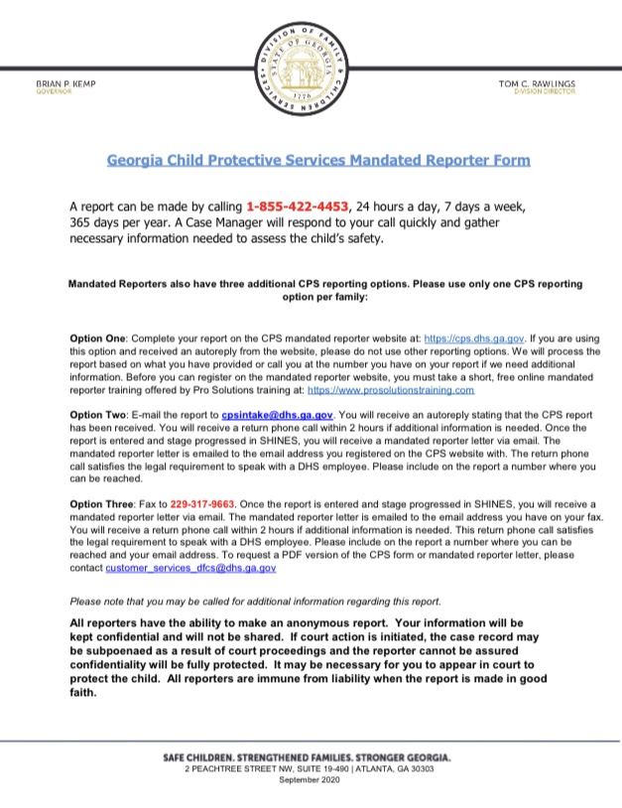
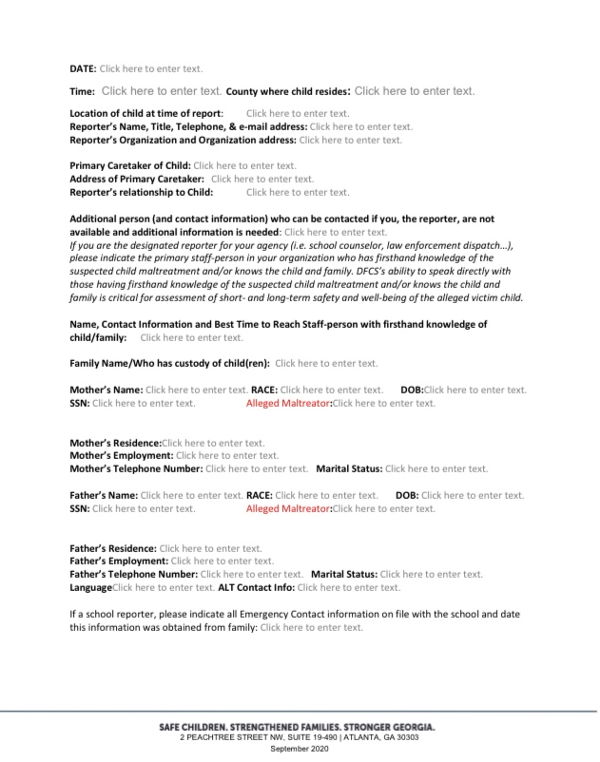
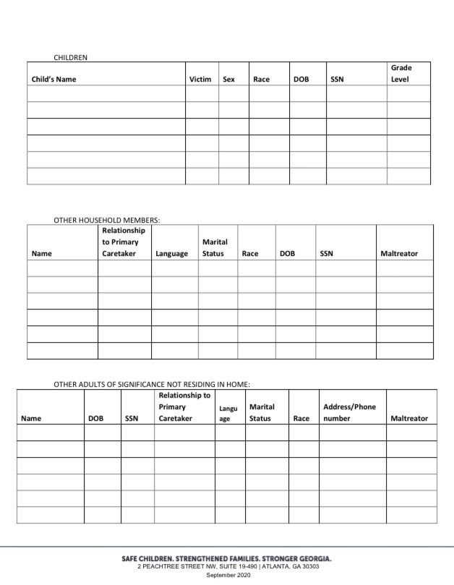
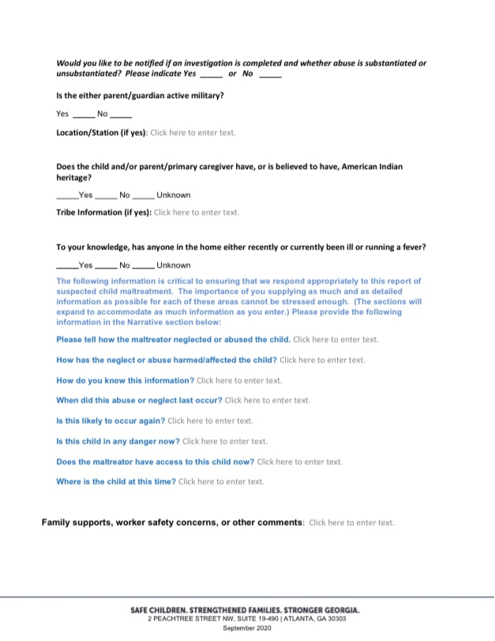

APPENDIX I: Additional Information Regarding Forensic Interviews and Evaluations
Forensic interviews and evaluations are conducted in a sensitive and unbiased manner that will support accurate and fair decision-making in the criminal justice and child protection systems. Forensic interviews are developmentally, culturally, and linguistically appropriate and allow for the child’s narrative recall of events. They are also conducted in a legally defensible manner, as no leading or suggestive questions are asked, and are video recorded. Additionally, they are designed to overcome potential legal obstacles related to the competence and objectivity of the interviewer; the quality of the interview; a child’s developmental stage and varying ability to recall events and use specific language; and the impact of the trauma on the child.
In general, a forensic interview is most appropriate for children aged 3-17 or 18 and over if the child is still in high school who have either 1) suffered physical abuse with injuries, severe negligence, emotional abuse, sexual abuse, or sexual exploitation, or 2) witnessed any type of violence including, but not limited to, domestic violence, rape, or murder. A forensic interview is likely appropriate when a child has made a disclosure regarding abuse; has medical evidence of abuse; or exhibits behaviors suggestive of abuse. Forensic interviews may also be appropriate based on special circumstances that may include young adults disclosing abuse that occurred during childhood, or adults with special needs who may have experienced abuse or exploitation. Children who are insufficiently verbal for an interview but who present with medical evidence of sexualized behaviors should be referred for multi-disciplinary review.
Forensic evaluations are a series of forensic interviews (between 2-6 sessions, typically as dictated by the needs of the child) and may be planned from the beginning or decided upon the initial forensic interview. Forensic evaluations may be warranted/appropriate/necessary when a child was unable to complete the initial forensic interview and needs additional time or to fit a particular child’s needs to engage/participate, which may be related to age, social/emotional/physical functioning, developmental/cognitive abilities or other special needs, ability to communicate, being multi-lingual and/or requiring an interpreter; multiple allegations, offenders and/or types of victimization, such as CSEC victims, long-term victims, or poly-victims; for those who have been severely traumatized; when the outcome of the initial forensic interview is inconclusive; or other reason when information could not be fully or effectively gathered in the single session. Forensic evaluations may also be needed when the child did not disclose abuse to investigators or during the initial forensic interview but there are other such concerning indicators or factors strongly suggesting possible victimization, such as sexualized behaviors, medical evidence or findings, statements of other children and/or adult witnesses, pornography, or access by known offender; child didn’t disclose to investigators or during the initial forensic interview but allegedly disclosed to some other person; the child disclosed additional information following the initial forensic interview or indicated the reason he/she could not disclose; external evidence or corroboration emerges; prosecution and/or child protective decisions cannot be made based on the initial forensic interview results; or due to changes in the situation/ circumstances.
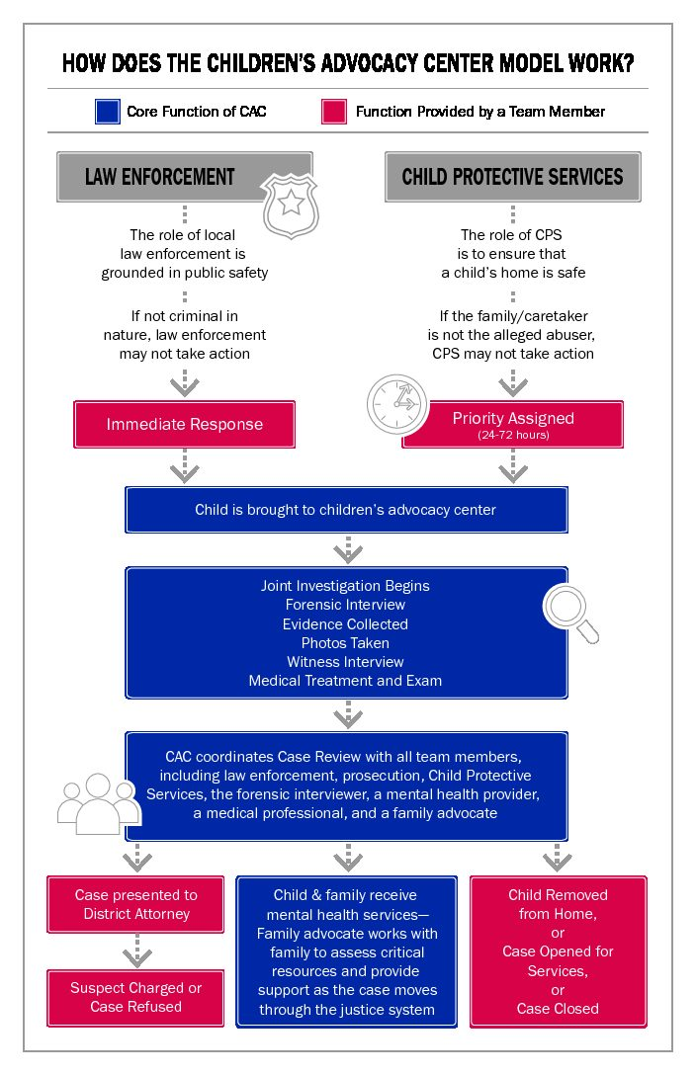

APPENDIX J: Children’s Advocacy Centers of Georgia CSEC Response Team
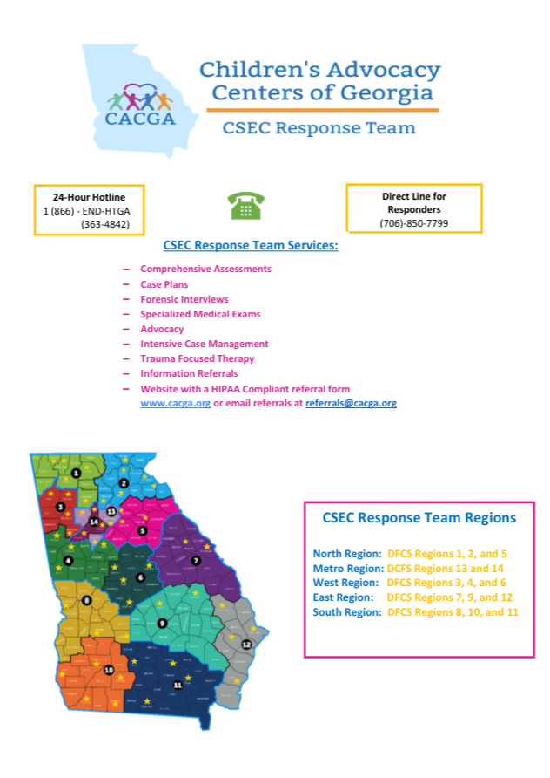

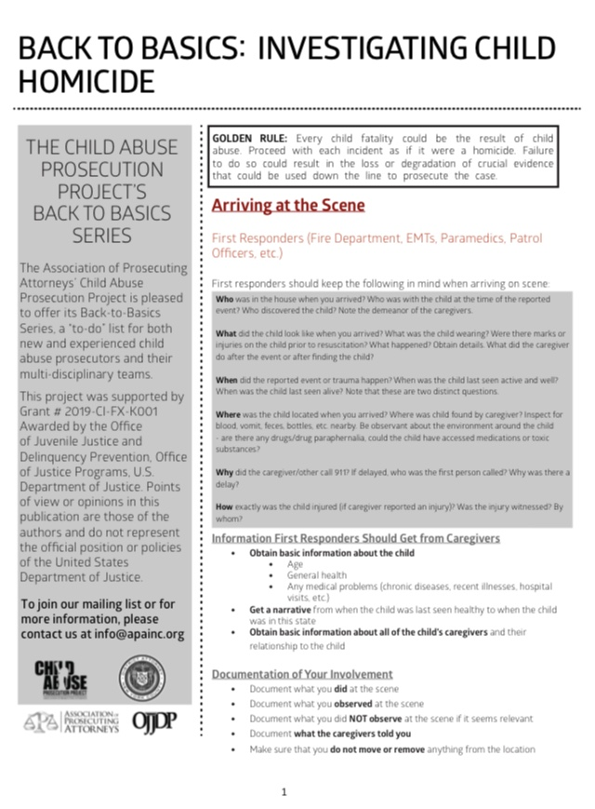
APPENDIX K: Investigating Child Homicide Factsheet
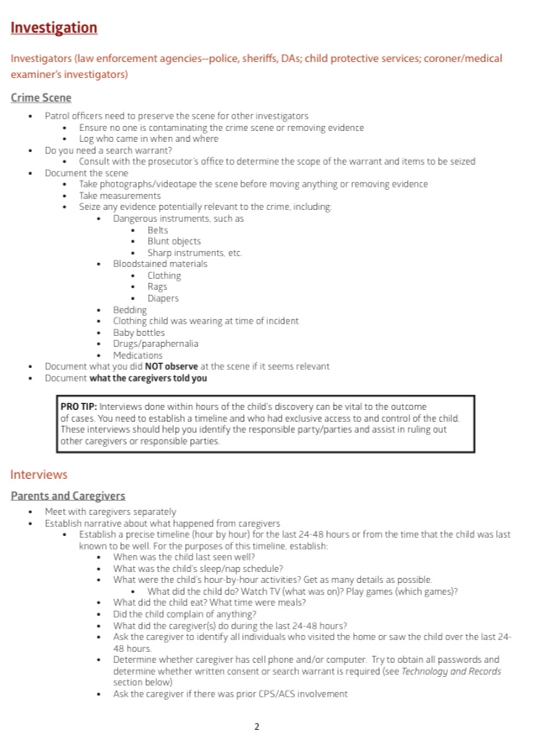
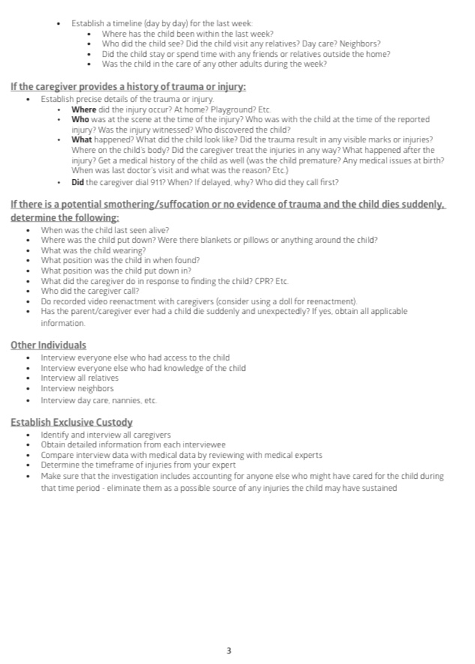
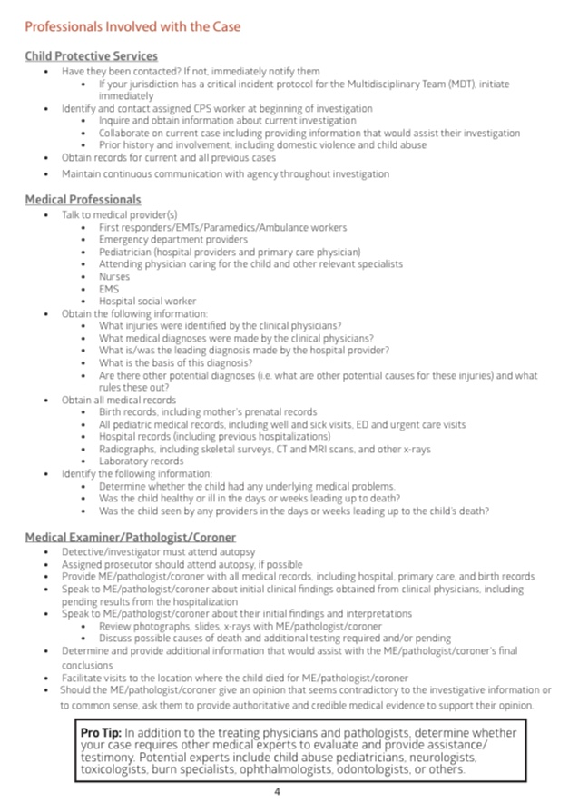

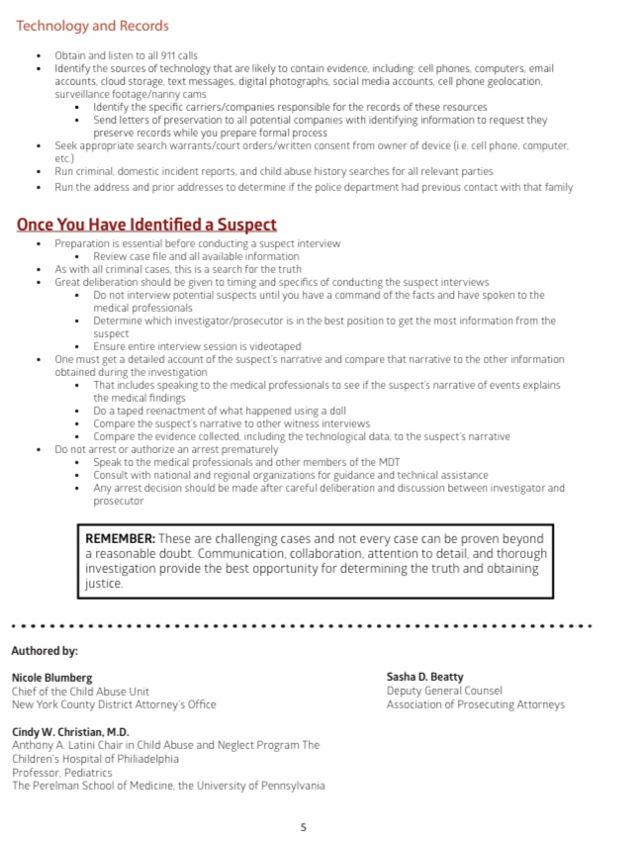

See O.C.G.A. §§ 19-15-5(a), 19-15-6, 49-5-41(a)(9), and 49-5-41(c)(5).
When a judicial circuit is composed of more than one county, the protocol committee shall determine if it shall be established for each county in the judicial circuit or if it will serve all of the counties within the judicial circuit. O.C.G.A. § 19-15-2(b)(3).
O.C.G.A. § 19-15-2(e).
See https://www.childwelfare.gov/topics/systemwide/cultural/disproportionality/ for further information on disproportionality in the child welfare system.
The chairperson is responsible for ensuring that written protocol procedures are followed by all agencies.
O.C.G.A. § 19-15-2(b) requires the chief superior court judge of the circuit in which the county is located to establish the protocol committee and appoint an interim chairperson who presides over the first meeting. The chief superior court judge is also tasked with appointing persons to fill any vacancies on the protocol committee. After the committee is established, the committee members elect a chairperson from the protocol committee’s membership.
If any designated agency fails to carry out its duties relating to participation on the protocol committee, the chief superior court judge of the circuit may issue an order requiring the participation of such agency. Failure to comply with such order shall be cause for punishment as for contempt of court. O.C.G.A. § 19-15-2(c)(6). If any member’s agency experiences an issue with the operation of the protocol, that member needs to initiate contact with any other agencies involved with the issue and work to resolve the matter. The resolution of the matter should be forwarded as soon as possible to the Chairperson for tracking purposes and inclusion in the next quarterly meeting.
Committees should consider identifying a prevention advocate who can serve as a liaison with community groups, focus team members on identification of strategies for prevention of child abuse in the community, assist with location of resources for prevention and intervention efforts, and advocate for implementation of identified prevention and intervention efforts. Many of the suggested additional members can help the committee ensure its actions and procedures are culturally relevant and appropriate while also building trust within the community and others on the committee.
In some cases, it will be necessary to work with peers and colleagues from different counties, jurisdictions, and states. These stakeholders should be approached in the same collaborative and cooperative manner.
Each agency subject to this protocol shall ensure that its employees are familiar with adverse childhood experiences (ACEs) and are trained to be trauma responsive. See https://www.childwelfare.gov/topics/responding/trauma/ for information on trauma-informed practice. It may be helpful to reference this self-assessment guide: https://www.nctsn.org/sites/default/files/resources/special-resource/trauma_informed_juvenile_court_sef_assessment.pdf. When operating in a trauma-responsive manner, it is helpful to ask, “What happened to you?” as opposed to, “What is wrong with you?”
In the event a member of the committee fails to adhere to the protocol or is routinely absent from committee meetings, an appropriate course of action should be pursued which may include: 1. Notification/reminder to the offending person(s) of the requirements and proper procedures; 2. Notification to the offending person’s immediate supervisor (continuing up the chain of command as necessary) of the failure to adhere to the protocol; 3. If not remedied, a subpoena may be requested to obtain cooperation; or 4. Revisions to the protocol, if any of its non-legally mandated provisions become outdated or are no longer practical. When determining the appropriate course of action, the committee shall bear in mind that the purpose of the protocol is to foster communication and cooperation amongst involved agencies.
O.C.G.A. § 19-15-2.
A sample annual report can be found in Appendix C.
O.C.G.A. § 19-15-2.
See Appendix F for prevention-focused protective factors and examples of prevention efforts.
Children who are abused may suffer from the following: immediate physical injuries; emotional and psychological problems; increased risks of injury; sexually transmitted infections; mental health problems; delayed cognitive development; reproductive health problems; and involvement in human trafficking. Research suggests that by stemming the early development of violent behavior, we can also reduce other types of violence to young people, such as youth violence, intimate partner and dating violence, sexual violence, and self-directed violence.
See https://www.childwelfare.gov/topics/preventing/prevention-programs to learn more.
Primary prevention activities support the general well-being of families and children and are directed toward the general public with a focus on preventing maltreatment before it occurs.
Secondary prevention supports families and children at higher risk for incidents of child abuse through early detection and intervention.
Tertiary prevention supports families and children after abuse has already occurred by intervening to prevent a recurrence of abuse and alleviating the effects of trauma and preventing additional trauma.
See Appendix F for examples of prevention efforts. Refer to Georgia’s Child Abuse and Neglect Prevention Plan (CANPP) found here: http://strengtheningfamiliesga.net/wp-content/uploads/2020/09/A-Vision-for-Child-and-Family-Wellbeing-in-Georgia-the-states-CANPP2020.pdf for further information on specific prevention efforts that communities may establish. Additional information and resources related to preventing child abuse can be found on Prevent Child Abuse Georgia’s website at https://abuse.publichealth.gsu.edu/.
Dependency proceedings may be commenced in the county in which a child legally resides; or in the county in which a child is present when the proceeding is commenced if such child is present without his or her parent, guardian, or legal custodian or the acts underlying the dependency allegation are alleged to have occurred in that county. O.C.G.A. § 15-11-125.
See Section 4.6 for further information regarding forensic interviews and evaluations.
Learn more here: https://www2.ed.gov/about/offices/list/ocr/disabilityoverview.html. Contact OCA for additional resources or training needed as it relates to the intersection of disability requirements and child welfare requirements.
While the focus of this section is on children, these laws pertain to people of all ages. It may be appropriate to also include procedures relevant to interacting with and providing appropriate accommodations to adults with disabilities within this protocol.
This includes physical disabilities as well as cognitive or developmental delays.
This may include adaptive equipment or adjustments to environments or processes.
For instance, someone may require an accommodation related to an interview but not related to accessing the physical location for the interview.
Determining appropriate accommodations will likely involve asking the person with the disability what specific accommodations that person needs.
This definition is found in O.C.G.A. § 19-7-5 and is relevant to mandated reporting. Similar and additional definitions of child abuse are included in O.C.G.A. § 15-11-2 and are relevant to legal proceedings conducted in juvenile court.
O.C.G.A. § 19-7-5(b)(4)(A).
Depending on the circumstances, truancy may be considered educational neglect and therefore treated as a dependency case or a status offense and therefore treated as a Child in Need of Services (CHINS) case. See O.C.G.A. § 15-11-2(11)(A)(i).
O.C.G.A. § 19-7-5(b)(4)(B). Neglect or exploitation may include “failure to thrive” or Factitious Disorder/Pediatric Condition Falsification/Munchausen Syndrome by Proxy (MSBP) Disorder.
O.C.G.A. § 19-7-5(b)(6.1).
O.C.G.A. §§ 19-7-5(b)(6.1)(A) and 16-5-70.
O.C.G.A. §§ 19-7-5(b)(6.1)(B) and 16-5-73.
O.C.G.A. §§ 19-7-5(b)(6.1)(C) and 40-6-391.
O.C.G.A. §§ 19-7-5(b)(6.1)(D) and 15-11-2(56).
O.C.G.A. §§ 19-7-5(b)(10), 19-15-1(3)(C), and 15-11-2(69).
O.C.G.A. §§ 19-7-5(b)(11), 19-15-1(12), and 15-11-2(70).
O.C.G.A. § 15-11-2(30). Although “emotional abuse” is not included in O.C.G.A. 19-7-5 for reporting purposes, it is included in the juvenile code. For reporting purposes, “emotional abuse” may be consistent with “endangering a child” or “neglect”.
Most if not all of the protocol committee members are mandated reporters. Mandated reporters and non-mandated reporters alike should be familiar with potential indicators of different forms of child abuse. A listing of these indicators can be found in Appendix G.
Mandated reporter training is available online or in person through Prevent Child Abuse (PCA) Georgia at https://abuse.publichealth.gsu.edu/free-online-mandated-reporting/.
More details can be found here: https://dfcs.georgia.gov/services/child-abuse-neglect. A sample mandated reporter form can be found in Appendix H.
The phone number for the CPS Intake Communication Center (CICC) is 1-855-GA-CHILD or 1-855-422-4453.
The email address is cpsintake@dhs.ga.gov. The fax number is 229-317-9663.
To use this option, DFCS requires the reporter to complete the Mandated Reporter Training at www.prosolutionstraining.com. This training is required one time and then the reporter will receive a code to use when making a web-based report.
Reporters should maintain their own records of reports made to DFCS.
If an address is unknown, it would help DFCS to be provided with any information about how to best get in touch with the child and family.
Photographs of a child’s injuries to be used as documentation in support of allegations by hospital employees or volunteers, physicians, law enforcement personnel, school officials, or employees or volunteers of legally mandated public or private child protective agencies may be taken without the permission of the child’s parent or guardian. Such photographs shall be made available as soon as possible to the child welfare agency providing protective services, the appropriate police authority, and military law enforcement. O.C.G.A. § 19-7-5(e).
O.C.G.A. § 19-7-5.
Refer to DFCS Policy found at https://odis.dhs.ga.gov/General for further information on DFCS’s processes for making an intake decision.
Law enforcement may remove a child from his or her home, without the consent of his or her parents, guardian, or legal custodian if a child is in imminent danger of abuse if he or she remains in the home; or a child is a victim of trafficking for labor or sexual servitude under O.C.G.A. § 16-5-46. O.C.G.A. § 15-11-133.
DFCS cannot remove a child without a court order. Local procedure, as outlined in this protocol, will determine the steps DFCS should follow to request a removal order from the juvenile court. The juvenile court will make a determination as to whether a removal is appropriate and either authorize the removal or deny the request.
See O.C.G.A. § 15-11-131.
Any removal requiring transportation of a child under the age of 8 or 4’9” must be done with an approved child safety seat or booster seat. O.C.G.A. § 40-8-76.
This may include the steps for contacting the court to request a removal order; whether DFCS or their SAAG makes such requests; whether the judge or an intake officer receives such requests; and whether there are specific procedures for work hours vs non-work hours.
This is necessary regardless of whether either agency will be actively involved on an ongoing basis. In some instances, this notification may need to happen immediately, depending on the severity of the circumstances. If the alleged offense occurred outside of the responding officer’s jurisdiction, that officer should advise the complainant and assist with filing a report with the appropriate law enforcement agency.
This is a complex area. A coordinated plan of action is necessary and may involve the following tasks: review all of the child’s available medical records; obtain verification of as many items as possible (records of drugs purchased, blood levels on child); seek report of child’s condition when parent is absent; if appropriate, video monitoring in hospital with plan in place to intervene if child is found to be in danger from perpetrator’s actions; follow up protection plan by DFCS; law enforcement and legal actions as dictated by evidence.
In many cases, this will require at least a basic assessment by DFCS as to the safety and appropriateness of the out-of-home placement and caregiver(s). In some cases, appropriate placement options may reside out-of-state. Georgia DFCS maintains border agreements with Florida, Alabama, Tennessee, North Carolina, and South Carolina; these border agreements may allow a child to be placed in a home across state lines within a matter of hours. See DFCS Policy 15.8 on https://odis.dhs.ga.gov/General for more information.
When appropriate, a re-enactment doll may be used to conduct a re-enactment with a suspect and/or witness. GBI’s Child Fatality Review Unit offers access to re-enactment dolls free of charge and may be contacted by calling 404-270-8715.
Nothing contained in this protocol shall be construed to require law enforcement and DFCS agree on any particular disposition.
Law enforcement and DFCS should ask only basic, non-detailed questions to allow for a more detailed interview by a trained interviewer through the local Child Advocacy Center.
Such procedures may include, but are not limited to, the following: law enforcement and DFCS will appoint one or more individuals to receive referrals daily from the other agency; law enforcement and DFCS will communicate regularly/daily/weekly to staff referrals; each agency will check their local files and criminal histories whenever possible prior to making a decision on the disposition of a referral and share the results with the other agency; each agency will inform the other agency regarding what action has been taken by that agency; each agency will staff/house personnel within the other agency.
This may include but is not limited to conversations with the alleged child victim, other children present, caregivers on scene or in an ambulance, or other household members, neighbors, bystanders, or witnesses.
This may include but is not limited to appearance/initial response of parents/caregivers on scene and observations around sleep environments even if the reason for involvement is not related to sleep safety.
The local protocol should include the specific name for the local MDT if such a name exists.
There are many factors that should be taken into account when evaluating a child’s best interests. These factors can be found in O.C.G.A. § 15-11-26.
This information may be used to assist with compiling the annual report.
http://www.decal.ga.gov/CCS/rulesandregulations.aspx.
https://www.nationalcac.org/forensic-interview-services/
See Appendix I for further detailed information about forensic interviews and evaluations.
Forensic interviewers are trained through nationally-recognized trainings which usually consist of an intensive three to five day course in which they learn the necessary skills to conduct an investigative forensic interview of a suspected victim of child abuse. Forensic interviewers must also have a minimum of eight (8) hours of specialized training on an annual basis and meet best practice standards as set forth by Children’s Advocacy Centers of Georgia (CACGA). Forensic interviewers maintain knowledge and skills related to a child’s development, memory, and suggestibility; children as witnesses; interviewing techniques; use of anatomical dolls; characteristics of abuse; false allegations; criminal codes; effects of childhood trauma and stress; and recantation.
This may also include FBI representatives in certain situations.
Refer to Section 4.4 Multi-Disciplinary Response for more information regarding multi-disciplinary team meetings.
Superior Court prosecutes felony offenses and hears child custody cases.
State Court prosecutes misdemeanor offenses.
Magistrate Court issues warrants and handles probable cause and bond hearings.
O.C.G.A. § 17-17-1 et al.
Dependency actions pertain to children who have been alleged to be abused.
Delinquency actions pertain to children who have been alleged of committing a crime.
CHINS actions pertain to children who have been alleged of committing a status offense, such as being unruly, truant, or running away. CHINS cases focus on whether a child is in need of care, guidance, counseling, treatment, rehabilitation or supervision relating to the status offense.
Refer to Appendix B for the best interest factors.
Refer to O.C.G.A. § 15-11-110 for specifics about continuances in dependency proceedings.
This may also include placing a child in the home of an appropriate relative or fictive kin pursuant to an Interstate Compact on the Placement of Children (ICPC) Border Agreement. See DFCS Policy 15.8 on https://odis.dhs.ga.gov/General for more information.
Also referred to as Intimate Partner Violence (IPV) or Domestic Violence (DV).
O.C.G.A. §§ 19-7-5(b)(4)(A) and 15-11-2(2)(A).
Children’s Healthcare of Atlanta (CHOA) is available for such consultation; contact CHOA at 404-785-7778 for additional information.
O.C.G.A. §§ 19-15-1(3)(C) and 15-11-2(69).
A victim-centered approach should be utilized during this process wherein the child has a say in whether or not they have an exam.
Referrals to CACGA for victims of human trafficking can be made via phone at 1-866-END-HTGA (842-4842), HIPAA-compliant web form at https://www.cacga.org/referral-form/ or email at referrals@cacga.org.
CHOA’s Stephanie V. Blank Center for Safe and Healthy Children offers multiple ways for community providers and partners to receive assistance with medical exams for suspected victims of abuse. The DFCS medical network allows for providers to receive second opinions from CHOA medical providers; contact CHOA at 404-785-7429 for additional information. There are monthly ECHO sessions where community providers present cases and there is a didactic lecture on relevant topics; contact CHOA at 404-785-6804 for additional information. CHOA also offers trainings; contact CHOA at 404-785-5004 or cpctraining@choa.org for additional information.
These may be conducted through the local Child Advocacy Center (CAC) or Sexual Assault Center (SAC) that has a Sexual Assault Nurse Examiner (SANE) and a Sexual Assault Victim Advocate (SAVA). Some CACs also have an on-site medical examination room. Children’s Healthcare of Atlanta (CHOA) conducts these exams. Hospital emergency rooms are able to conduct medical evaluations for the health of the child. Some hospitals may have a pediatric SANE who can conduct the sexual assault examination. If the child is taken to the Receiving Hope Center (RHC), this exam may be conducted there.
While the physician, nurse practitioner, or physician assistant providing care for the child can conduct the medical evaluation, it is preferable for the forensic evaluation to be performed by a provider with expertise in child maltreatment. Experts include child abuse physicians, or other physicians, nurse practitioners or physician assistants with specialized training and experience in child abuse, Sexual Assault Nurse Examiners (SANEs), Sexual Assault Forensic Examiner (SAFEs), or Sexual Assault Medical Forensic Examiners (SAMFEs). SANEs receive specialized training in conducting exams with adults, adolescents and/or pediatrics. SANEs should have physician oversight as they cannot render a diagnosis. Medical professionals are encouraged to seek help from experts when possible by referring the patient for specialized care, by requesting phone consultation, and/or by obtaining a second opinion review of exam photos. A second opinion is especially critical if an inexperienced provider reports positive findings upon exam. For names of local experts, providers should contact the nearest CAC, SAC, CHOA (404-785-3833) or CACGA (770-319-6888).
The National Protocol for Sexual Assault Medical Forensic Examinations – Pediatric recommends the provision of timely access to victim advocacy services during the exam process. Victim advocates typically function to aid victims and their families in getting help to cope with the impact of sexual abuse in their lives and to promote healing. Advocates also encourage coordination and collaboration among responders so that interventions are child-focused and trauma-informed.
Victims of sexual assault may come to a hospital located outside of their county or state of residence or outside of the jurisdiction where the assault took place. The law enforcement agency in the jurisdiction where the assault occurred is the law enforcement agency charged with investigating the assault and facilitating transfer of the evidence collected from the hospital to the appropriate forensic lab in the jurisdiction where the assault took place.
O.C.G.A. §§ 19-15-1(12) and 15-11-2(70).
See Appendix G.
This is required by O.C.G.A. § 16-5-47. The notice is available through GBI; see https://gbi.georgia.gov/human-trafficking-notice. Protocol committees should ensure this notice is in the required places throughout the county/circuit.
https://djj.georgia.gov/commercial-sexual-exploitation-children.
Referrals to CACGA for victims of human trafficking can be made via phone at 1-866-END-HTGA (842-4842), HIPAA-compliant web form at https://www.cacga.org/referral-form/ or email at referrals@cacga.org.
During regular business work days, this notice should be provided to the unit’s agent on call via 404-270-8870. On nights, weekends, and holidays, this notice should be provided to the unit’s agent on call by calling the GBI communications center at 404-244-2600 or 1-800-282-8746. For further information: https://investigative-gbi.georgia.gov/investigative-offices-and-services/specialized-units/child-exploitation-and-computer-crimes-unit.
Referrals to CACGA for victims of human trafficking can be made via phone at 1-866-END-HTGA (842-4842), HIPAA-compliant web form at https://www.cacga.org/referral-form/ or email at referrals@cacga.org.
If a child is denying victimization, and/or is not cooperative, it may be better to delay the forensic interview until some trust has been established with the child.
The assessment may also include a medical evaluation or mental health assessment.
Therapy is an integral part of treatment for many children who have been sexually exploited. Therapists must be knowledgeable about trauma and skilled in the delivery of trauma-focused treatment in addition to being well-informed about sexual exploitation.
Evidence may include, but is not limited to, the following: electronic devices, numbers, and records; online ads, screenshots of applicable internet sites, usernames and passwords for accounts, or other electronic activity; photographs of victim and scene where victim was located; photographs of victim’s tattoos and what they mean to victim; relevant security video; hotel workers’ statements and hotel records, if applicable; ‘exploitation clothing’ worn by the victim; anything bought for the victim by the accused person; sheets, blankets, and condoms; fake or stolen IDs along with statements from ID victims; and anything that can corroborate the victim’s statement, potentially including a receipt, journal, diary, calendar, or agenda.
It may be necessary to put a cell phone in airplane mode or in a faraday bag to prevent the cell phone from being remotely wiped. It may also be necessary for law enforcement to submit a preservation letter to social media sites.
Traffickers fit the definitions of a “caregiver” or “person responsible for the care of a child” found in O.C.G.A. § 15-11-2.
DFCS’ State Office Care Coordination Treatment Unit (CCTU), formerly known as the Placement Resources Operations (PRO) Unit may serve as a support for county DFCS offices to assist with finding an appropriate placement for a child in DFCS custody.
Referrals to the Receiving Hope Center (RHC) may be coordinated through CACGA or directly to RHC via email at RHCreferrals@wellspringliving.org or phone at 470-467-3669.
This is a federal requirement through the Child Abuse Prevention and Treatment Act (CAPTA) for the state as a whole and is not necessarily a requirement for DFCS specifically. However, DFCS maintains policies related to plans of safe care (see DFCS Policy 19.27 available through https://odis.dhs.ga.gov/General) and is typically well-situated to coordinate and partner with other agencies to develop, implement, and monitor this plan. Even when DFCS is not involved, this Plan of Safe Care is still required and this protocol should include procedures for determining which agency will maintain responsibility for monitoring the Plan of Safe Care. (Responsibility may change from family to family and be assigned as the need arises during a Plan of Safe Care meeting.)
When customizing this protocol, ensure that procedures for determining which agency will take responsibility for monitoring the POSC are included.
Prenatal substance use may constitute “prenatal abuse” as defined in O.C.G.A. § 15-11-2(56): “exposure to chronic or severe use of alcohol or the unlawful use of any controlled substance…which results in: (A) Symptoms of withdrawal in a newborn or the presence of a controlled substance or a metabolite thereof in a newborn’s body, blood, urine, or meconium that is not the result of medical treatment; or (B) Medically diagnosed and harmful effects in a newborn’s physical appearance or functioning.”
Family dependency treatment court is a type of accountability court that has realized significant success in helping parents with substance use concerns and should be considered a viable option when the jurisdiction has such an accountability court in existence. If your jurisdiction does not have such an accountability court in existence, consider establishing one. Learn more here: https://cacj.georgia.gov/.
All protocol committee members should consider becoming trained in Youth Mental Health First Aid to learn how to help a child who is experiencing a mental health or addiction challenge or is in crisis. Learn more here: https://www.mentalhealthfirstaid.org/population-focused-modules/youth/.
Refer to Section 4.2.1 “Children with Special Needs” for further information.
GCAL is available 24 hours a day, 7 days a week and 365 days a year to help you or someone you care for in a crisis. GCAL professionals will: provide telephonic crisis intervention services; dispatch mobile crisis teams; assist individuals in finding an open crisis or detox bed across the state; link individuals with urgent appointment services; and help you access a local state funded provider for non-emergencies.
https://dbhdd.georgia.gov/bh-prevention/suicide-prevention
https://www.span-ga.org/
https://gbi.georgia.gov/CFR
https://dbhdd.georgia.gov/locations/community-service-board
In this section, it may be appropriate for local protocols to identify and incorporate information regarding which agency specific first responders will provide information to. It may also be appropriate to include additional specific information that law enforcement, DFCS, or other protocol members may find necessary and helpful.
It may be helpful to identify a local contact person to ensure they are made aware of the need to review a case as part of the local Child Fatality Review (CFR).
Statewide, sleep-related deaths and suicides continue to be a leading cause of death for children in Georgia. There are statewide initiatives underway to provide awareness and prevention. Additional local efforts may also be included here.
Some jurisdictions have previously opted to include the protocol for the local child fatality review committee within the local child abuse protocol. This would be an appropriate place to include this information if the jurisdiction so chooses.
The Child Welfare Information Gateway provides a very comprehensive free manual which provides an overview of the treatment of sexually abused, physically abused, and neglected children. The manual may be found at https://www.childwelfare.gov/pubs/usermanuals/treatmen/.
Therapy should be trauma-focused. Many providers utilize trauma-focused cognitive behavioral therapy (TF-CBT), which is widely regarded as the most effective treatment for sexually abused and traumatized children. Other treatment modalities that are trauma-focused may include, but are not limited to, talk therapy, play therapy, and animal assisted therapy.
The primary involved agency will provide additional assistance in selecting a provider based on the needs of the child, the financial resources of the family, and the availability of the provider. The provider selected should be a licensed clinician trained and experienced in the treatment of child abuse and trauma.
The CAC provides the following services: (insert services the CAC provides; these may include: forensic interviews; forensic evaluations; coordination of MDT meetings; court testimony; court preparation; individual therapy; group therapy; assessment and referrals; resource library materials; parent education/support groups; sexual abuse prevention education and training; lectures, workshops, and other educational presentations). These services are offered in (insert the language(s) offered by the CAC) and are free of charge (adjust this if there is a cost or potential cost for services).
Treatment for perpetrators may involve an evaluation of the perpetrator’s mental status and social and psychiatric history, and will include recommendations, which may involve counseling or other treatment.
While these terms are technically slightly different in definition, each of them have similar effects on child welfare professionals and the prevention and intervention opportunities are largely similar.
Resources include: https://www.acf.hhs.gov/trauma-toolkit/secondary-traumatic-stress; https://www.nctsn.org/trauma-informed-care/secondary-traumatic-stress; https://ovc.ojp.gov/program/vtt/what-is-vicarious-trauma; https://www.compassionfatigue.org/; https://www.who.int/news/item/28-05-2019-burn-out-an-occupational-phenomenon-international-classification-of-diseases; https://www.ncbi.nlm.nih.gov/books/NBK279286/; https://www.mayoclinic.org/healthy-lifestyle/adult-health/in-depth/burnout/art-20046642
This list of indicators is not exhaustive and these indicators may suggest abuse but any one indicator or multiple indicators may not necessarily mean that a child has suffered abuse. Indicators should be considered as red flags necessitating further inquiry.
Refer to CHOA training for more in-depth discussion and training of medical signs of abuse; contact CHOA at 404-785-5004 or cpctraining@choa.org for additional information.
"Emotional abuse" means acts or omissions by a person responsible for the care of a child that cause any mental injury to such child's intellectual or psychological capacity as evidenced by an observable and significant impairment in such child's ability to function within a child's normal range of performance and behavior or that create a substantial risk of impairment, if the impairment or substantial risk of impairment is diagnosed and confirmed by a licensed mental health professional or physician qualified to render such diagnosis. O.C.G.A. § 15-11-2(30).
Regardless of the number of sessions, best practice indicates that forensic interviews are: linguistically appropriate; purposeful in nature (a valid reason can be articulated for conducting more than one interview); forensically sound; non-duplicative; neutral and objective; child-friendly; child-focused; developmentally appropriate; and culturally competent.
Although normally best practice suggests that children should have a forensic interview as soon as possible, interviews with children who have been sexually exploited may require an interval of time to assess their readiness to be interviewed. More than one forensic interview, or a forensic evaluation/extended forensic interview, may be required due to dynamics related to exploitation. The format and dynamics of interviews involving sexual exploitation may differ from sexual abuse cases due to additional special considerations such as: a history of sexual abuse, physical abuse, neglect and/or domestic violence in the home; victims not identifying themselves as victims; victims having a strong distrust of authority; victims fearing for the safety of their families or others due to threats made by their exploiter; and victims rejecting any outreach that is perceived as condescending.

